**Section 8 done: 40/40 A Real App: The Burger Builder (Basic Version)**\* It’s time to build a real React application so that we can see all these concepts come together so that we can get an idea how we actually plan such an application and how we build this tree of components and successfully use all the concepts we learned thus far, in an application.  
**Planning an App in React - Core Steps**  
* You can break this up into more granular steps but these are the 3 important steps I see.  
**1) Component Tree / Component Structure**  
=> You probably got a design by your designer or you basically created the app design and now it’s up to you to split this app into React components and it’s absolutely normal that the result that you may have at the end might look different than your initially planned component tree. But it’s super important to have an idea about what should go into its own component and what not.  
**2) Application State (Data)**  
=> You can also translate this with the data you plan on using and manipulating in your application. For example - and of course you will do this over the next lectures - in our Burger application we need to keep track about the ingredients that user added because that will determine what we need to render and also what the user needs to pay in the end.   
**3) Components vs Containers**  
=> Now once you know the component structure of your application and the state you’re going to use in it, you can plan components vs containers. Which components should be Stateless/Functional/Dumb/Container Components and which components have to be Stateful Component because they need to manage some state and distribute it down to the Stateless Components. And as you will see we might then even add more components then we initially planned because we see that we can split up even more or maybe that some split we did plan doesn’t make sense once we start implementing it. And that’s perfectly normal. But having a plan is of course very important.  
**Planning our App - Layout and Component Tree**  
* For this of course we need to define what our application actually is and what it should be able to do.  
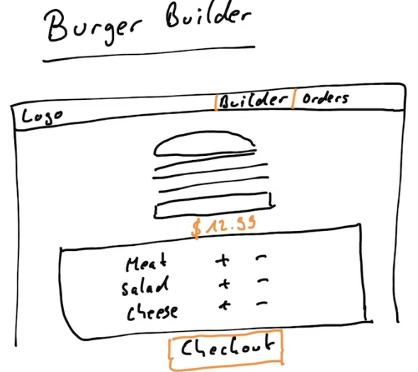  
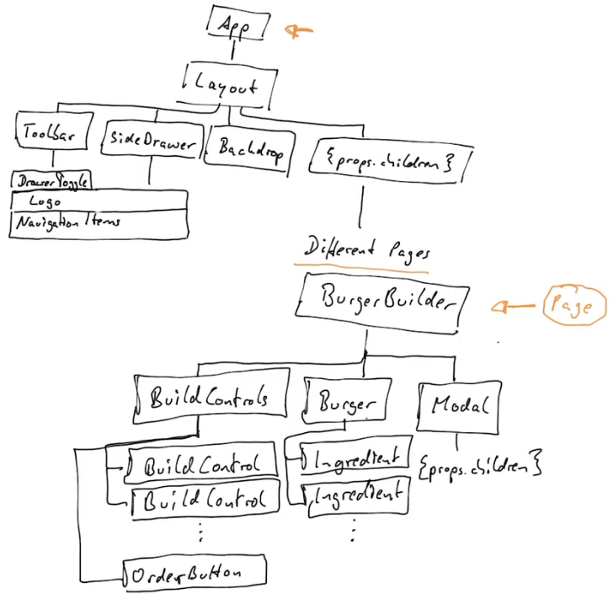  
=> the {props.children} in Layout - we want to have something which we can dynamically wrap, so whichever page you wanna display. Later in the app we’re going to add routing so that we can navigate to different pages so we might want to display the BurgerBuilder page or the Checkout page but all pages are going to share that layout. So we’re essentially going to use {props.children} here, allowing us to dynamically pass a component into depending on which page we wanna view.  
* The Modal probably should just be a wrapper component which in the end takes {props.children} to wrap itself around any content we wanna render in a modal so that we have a reusable modal, we could theoretically use for all kinds of stuff.  
=> Displaying our confirmations message, an erro message, or the order summary as we plan to do.  
* These are probably not all the components we’re going to add, but it is a good overview of our tree.  
=> We see that everything starts with 1 root component here - and then we split the tree up having a layout which could be a part of the root component and then having all the different branches.   
* Now here where we have the BurgerBuilder, this will be kind of like a page. It is a normal component but we probably will add more pages throughout this course when we start adding a page where we can see all past orders and stuff like that.  
**Planning the State**  
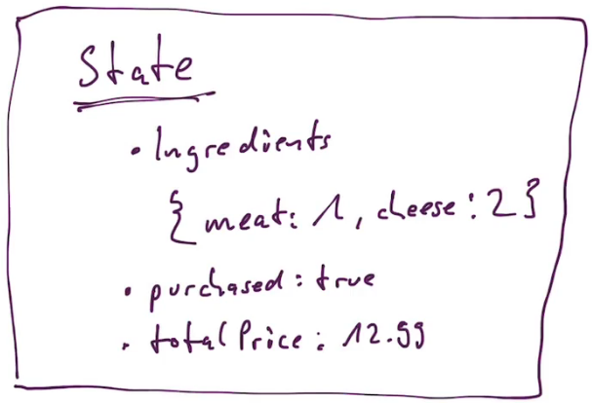

* Now where do we manage that state?   
=> You could say we should manage the state in the App component here at top. But I don’t agree with that.  
=> Instead, we should do it in the BurgerBuilder. Why? Because the state we listed is really just related to building a burger. If we later add a new checkout page or something like that, then we will basically have a page where we wanna see all orders of the user and we’re not interested in the ingredients of the burger the user currently builds.  
* Now the App.js component by default in a new project is a Stateful component created with the `class` keyword, we can of course always leave it to be one but we can also turn it into a dumb component if we wanted to.  
* Now if we’re thinking about PureComponents or shouldComponentUpdate(), we’ll implement this as we build the application and see if we can identify some places where we need to optimize our update cycle. But due to the simplicity of our state and the structure of our application here, it might also be the case that we never need to implement a PureComponent because we know that if the state or some props changes, it did really change, that we don’t have a button which might just set the state to something it was already at.  
**Setting up the Project**\* First we start the project with create-react-app.  
* Here we first want to enable CSS Modules so that we can make sure that the CSS classes we create in a CSS file can be scoped to a specific component in our application so that they are not applied globally when we would accidentally reuse the same CSS class.  
=> For that we need to `eject` the project.  
**npm run eject**  
=> In webpack.config files:  
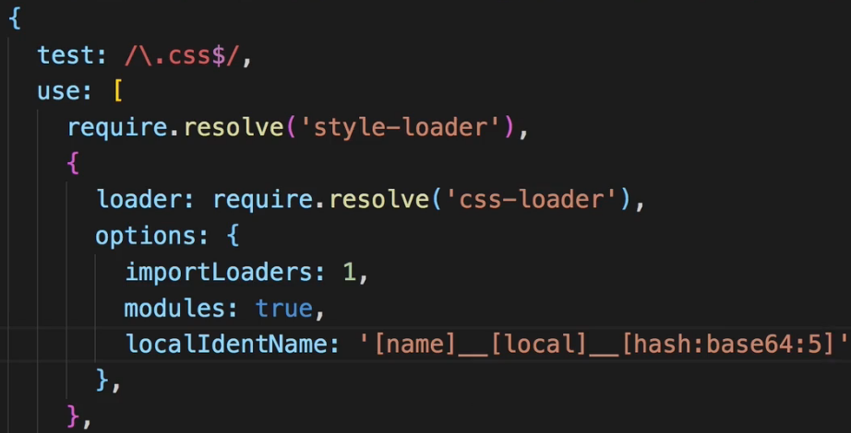 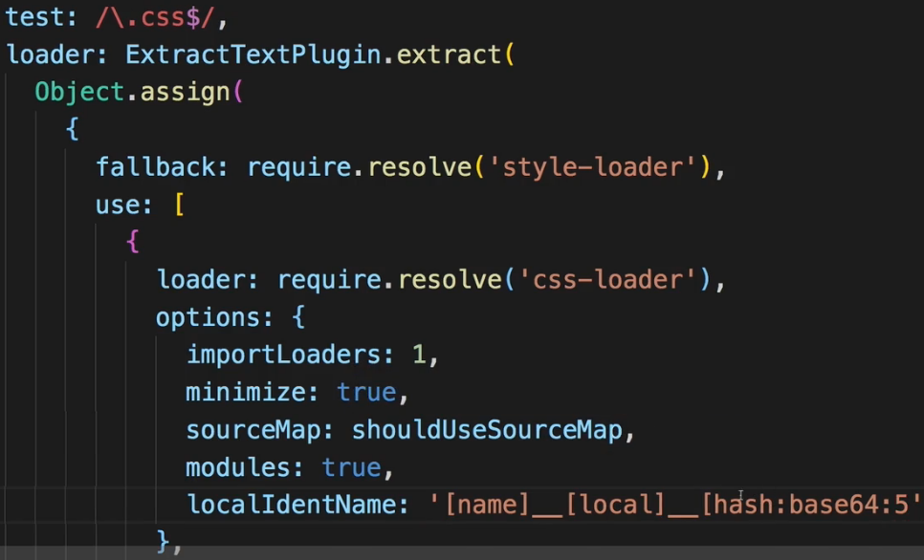  
* Now we have our project set up and we can get get started.  
* Let’s do some cleanup work - let’s remove that logo.svg and clean up the code in App.js, we can delete the App.css.  
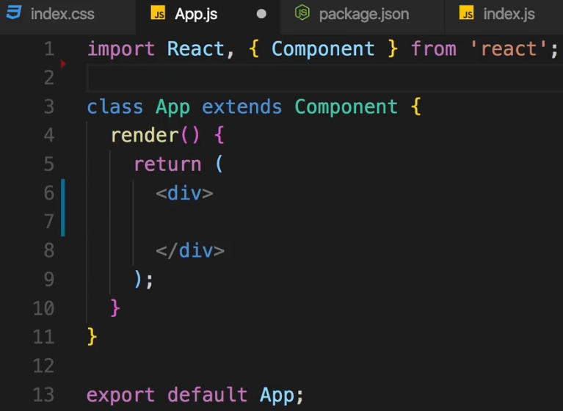  
* We can keep the index.css file and change the font there and still have it imported normally globally in the index.js file.  
=> Google Fonts > Open Sans > Customize > regular 400, bold 700 > Embed > copy the CDN link to the `public` folder and to the index.html file, and there add it right above the title. We’ll also adjust the title.  
  
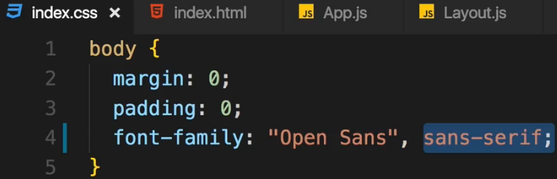  
=> Have Open Sans as our main font and have Sans Serif as a backup font.  
* With that the setup of the project is pretty much finished. We can now start writing our React application and implement that Component Tree we designed.  
**Creating a Layout Component**  
* I first of all will create that Layout component which will kind of be a wrapper, implementing the Toolbar and the BurgerBuilder in.  
* And later once we add routing and more pages to our application, we’ll take advantage of this Layout where the Toolbar will always be there but where we will then switch the page which is rendered in the content area of the Layout so to say.  
* Now we could simply turn the App.js file into a Layout because it basically is the root component of our application and that would be a perfectly fine approach. I will still create a separate component for that though, to have a component entirely focusing on the layout.  
* It is a typically project setup you use in React - having a `components` and `containers` folder.  
* Other folders you often see are `assets` - we will use this later once we add a logo.  
* And you might also have a folder for the Redux Store and so on - we will add it once we got that.  
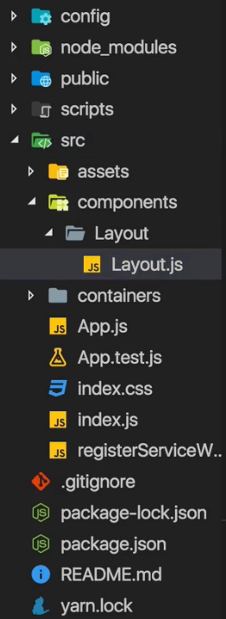  
* We will later replace the placeholder div with the 3 components.  
* In the <main> there I want to output the component we wrap with this Layout.  
* Now this allows us to simply use this Layout component as a wrapper around the core content component we wanna render to the screen.  
* We use HOC for having adjacent elements - NEW in React 16+ is the **FRAGMENTS <> </>**\* In this video we use our HOC we learned about.  
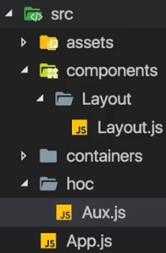  
* In Aux.js:  
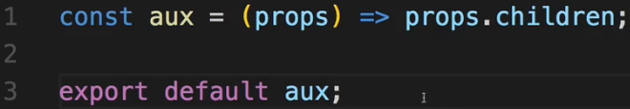  
* In Layout.js:  
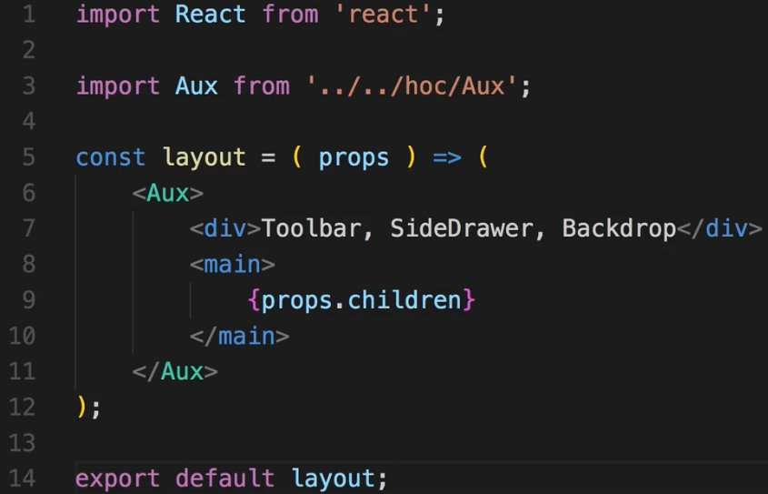  
* Now granted you could also go to the index.js file, import Layout here and simply ReactDOM.render() the Layout function as the root component. That’s basically the same solution as making the App.js file the root component. That wouldn’t be wrong. It’s just my personal decision to have this root component in case I should ever decide to restructure the app, add some state to my root component, maybe conditionally render different layouts or do anything like that.  
* In App.js:  
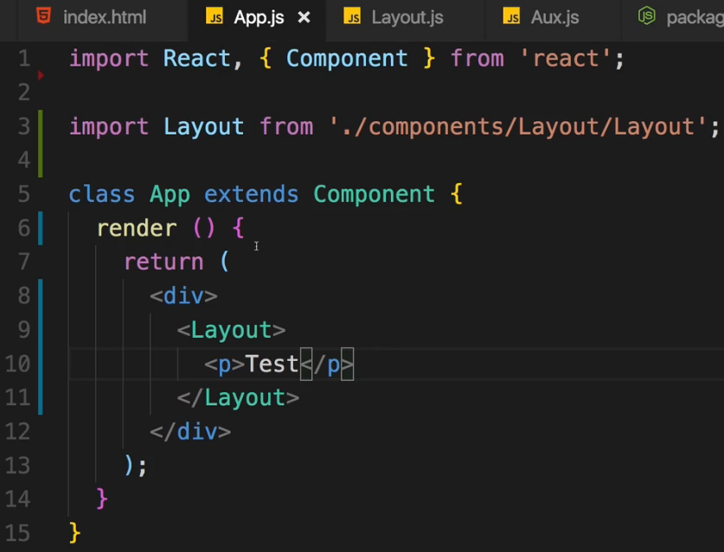  
* The Layout shouldn’t be a self-closing component because the idea behind the whole Layout is that I can wrap another component with it.  
* Later we will wrap a real component - the page we actually want to display - with it.  
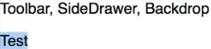  
* Now we got the roof of our application finished for now.  
**Starting Implementation of The Burger Builder Container**\* Now this will probably grow as we build this application. For example we might also return a modal here conditionally if it’s about the time to show it. But for now we want to render 2 different things.  
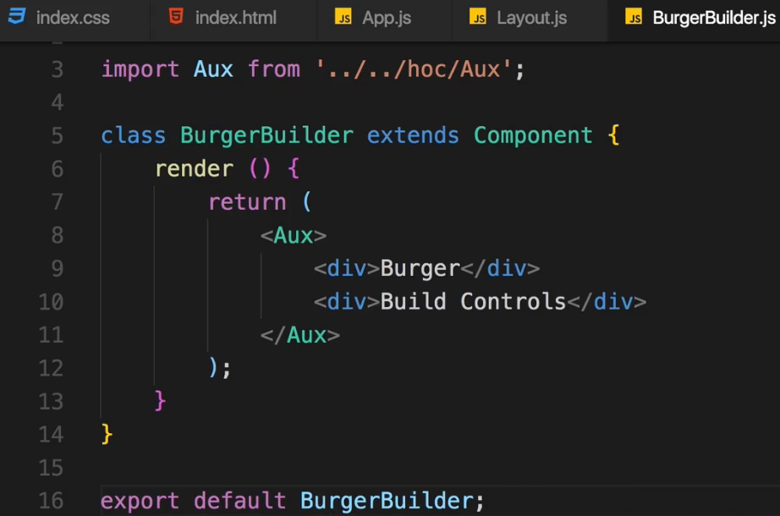  
* In App.js:  
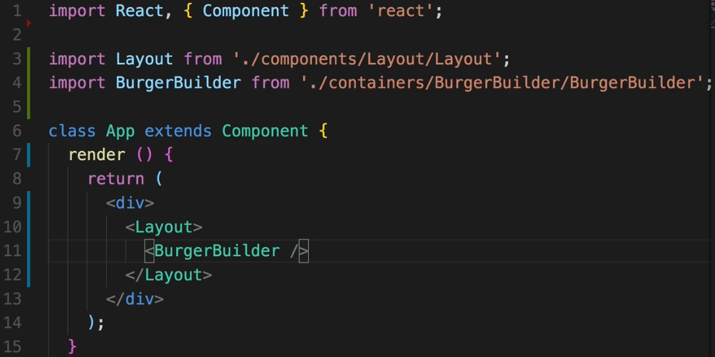  
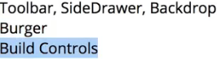  
* Now let’s add a bit of styling like a margin to at least separate them. And we will do this in the Layout.js component because it’s there where we have the area for the toolbar and the area for the main part.  
* In Layout.css: In Layout.js  
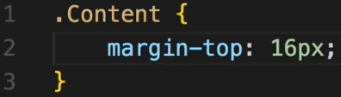 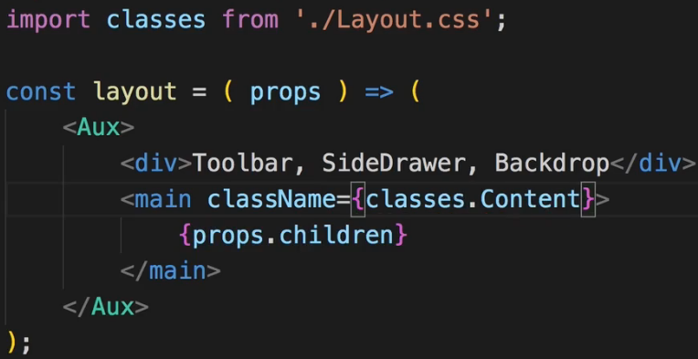  
**Adding a Dynamic Ingredient Component**\* You can download the BurgerIngredient.css file - using CSS only.  
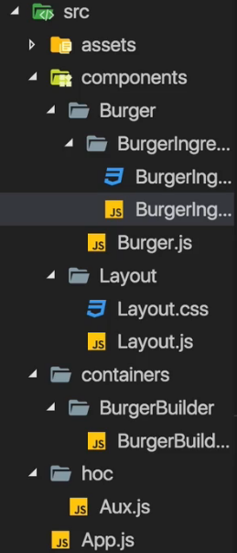

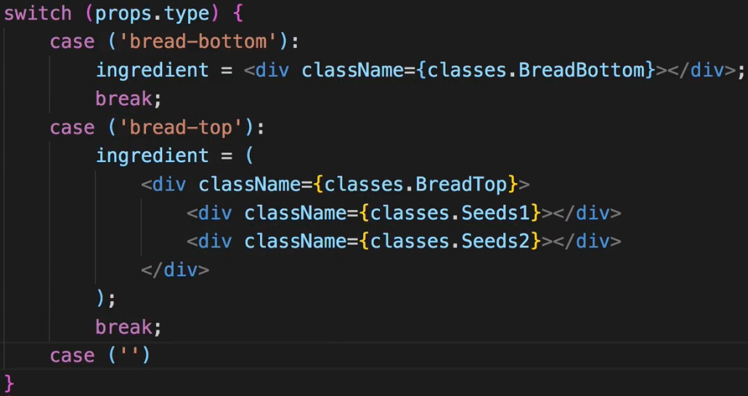  
=> We use case for each of the css classes we created in BurgerIngredient.css.  
* There are of course alternatives to this switch statement.  
* We set default: ingredient = null;  
* After that switch statement we can safely return that ingredient here. It’s either null or one of our many DIVs.  
* We can add PropType validation to it because we wanna make sure that we do receive a type property.  
**Adding Prop Type Validation**  
**npm install --save prop-types**  
  
=> You can use PropTypes only in Stateful components.  
=> You could add it to the containers folder but we still don’t plan on managing any state here or passing down any state to any other component, so for me it still stays a dumb/Stateless component, a normal Stateless component. That doesn’t change just because I create it with the `class` keyword. And that is generally important thing to understand - you don’t decide if something is a container or not with the `class` keyword. You can create all your components as a class if you want, it’s just a good practice to use the Functional form as often as possible but it’s not a must.  
=> Changing BurgerIngredient to a class.  
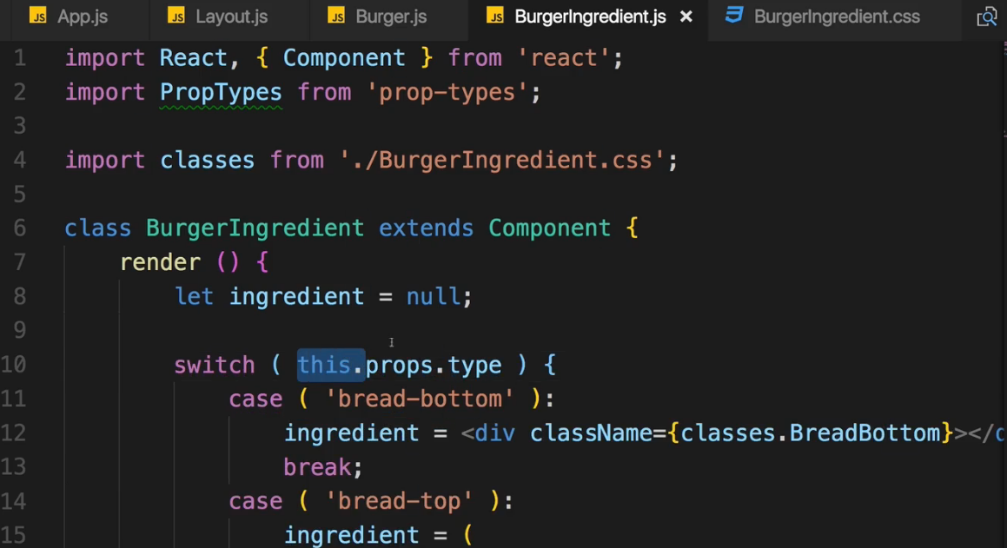  
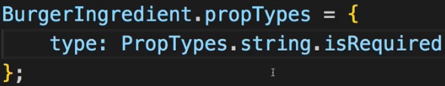  
=> So if we ever try to use the Ingredient component without passing a type, we will get an error.  
**Starting the Burger Component**  
* We will re-visit this component to enhance it and conditionally render something else later.  
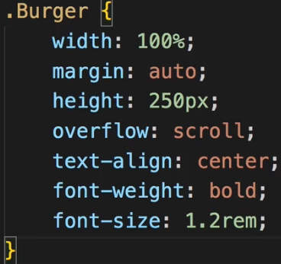  
* So this is the layout I wanna use, it’s the mobile layout though.  
* I now want to create a media query here to adjust it for larger screens.  
* The min-height: 700px is important because the Burger of course is built vertically.  
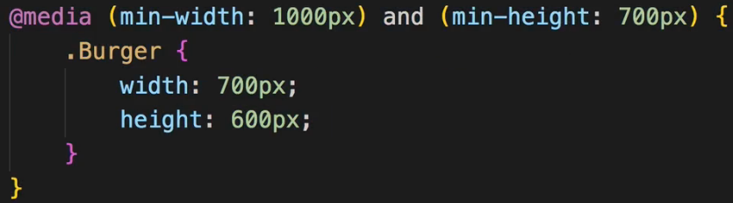  
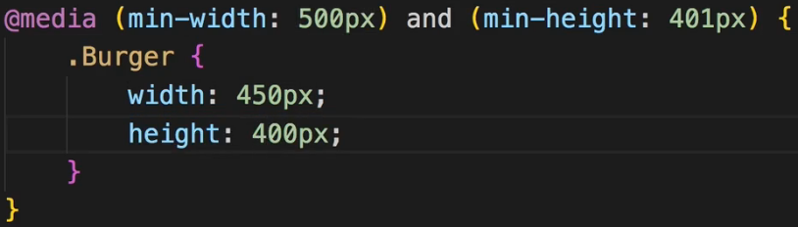  
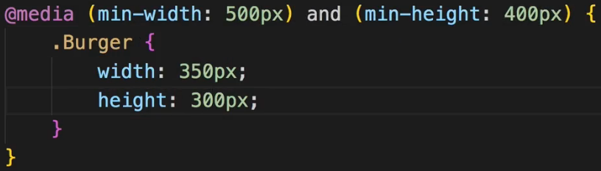  
* To also handle devices that are not that wide but pretty tall = in portrait mode.  
* There the class is always .Burger, the media query doesn’t matter for that.  
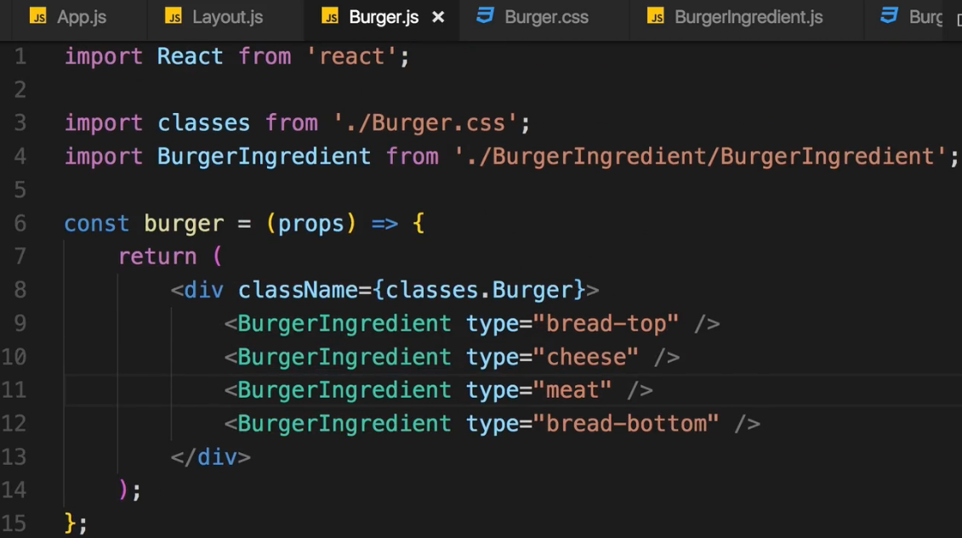  
* Now let’s simply render this burger.  
* In BurgerBuilder.js:  
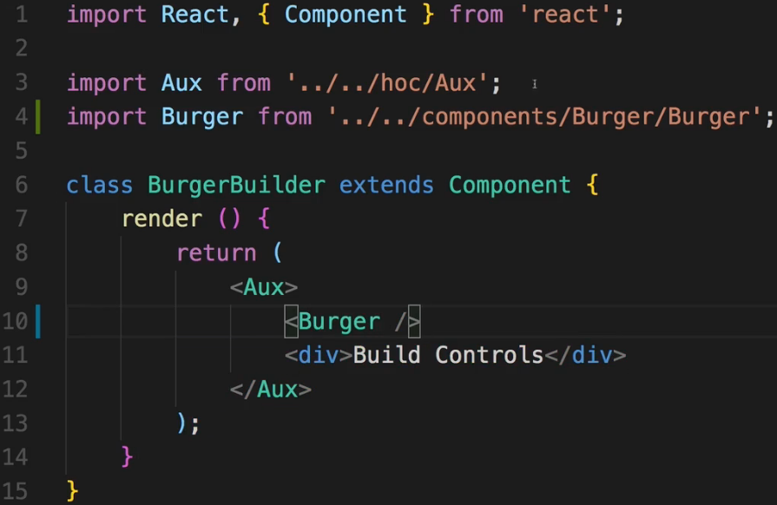

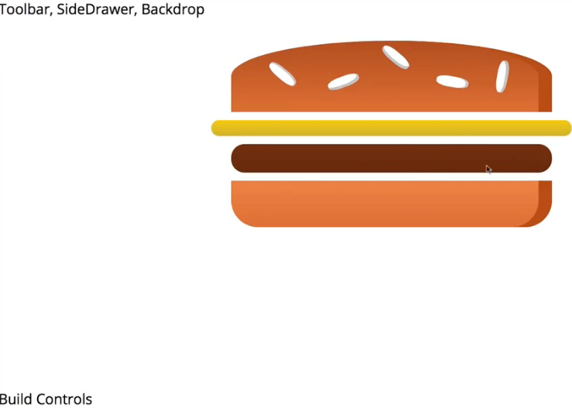  
* Right now everything about the Burger is now hard-coded. We’re not able to change this Burger dynamically and we’re not even rendering this dynamically. So let’s start by managing the ingredients via state and rendering the Burger dynamically.  
**Outputting Burger Ingredients Dynamically**  
* To create a state you can use either of these:  
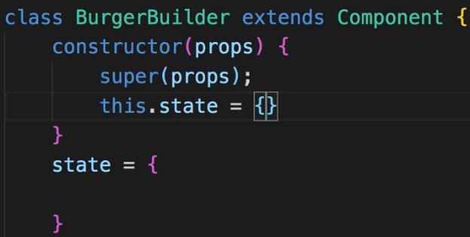  
* I’ll use this a bit more modern - because it’s shorter.  
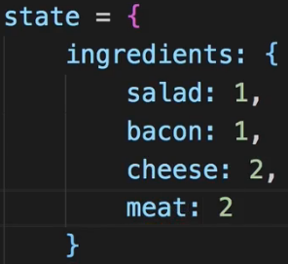  
* In BurgerBuilder.js:  
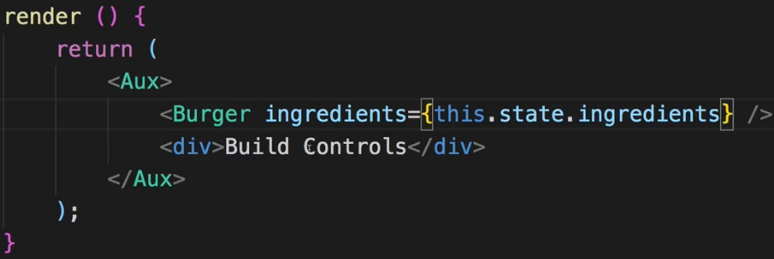  
* It’s an object, it’s not an array. So we can’t use .map() on that, we can’t just loop through that.  
=> Instead, we have to transform this object into an array and to be precise - we have to convert this object into an array of the values of the ingredients.   
=> Using **Object.keys()**  
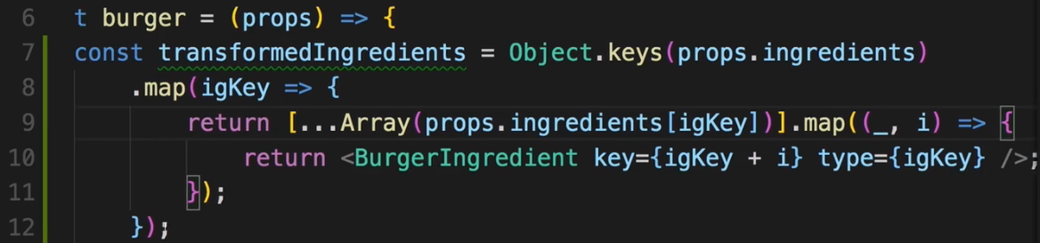  
=> It’s just a way of transforming an object of key-value pairs into an array of BurgerIngredients where the value of that object is important for me to decide how many ingredients I need and the key is important for which type of ingredient I need.  
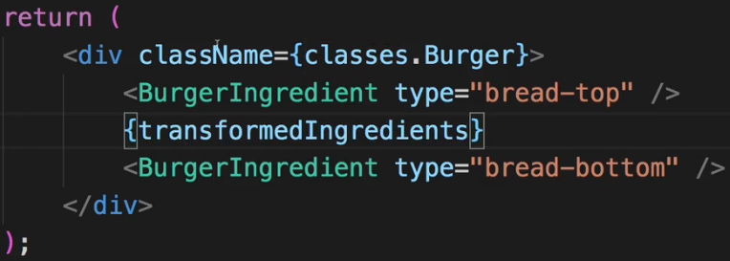  
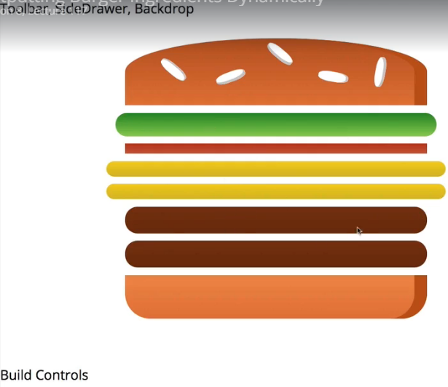  
* Now we have a generic map method of outputting ingredients.  
**Calculating the Ingredient Sum Dynamically**  
* What happens if we have a burger which starts with all ingredients set to 0 though?  
  
=> Would be nice to add something like a message in this case.  
* No to show something if we have no ingredients, we have to find out if we have no ingredients. The transformedIngredients is going to be an array of empty arrays in the end. But that is something that is kind of hard to check for us.  
=> We can reduce the transformedIngredients array.  
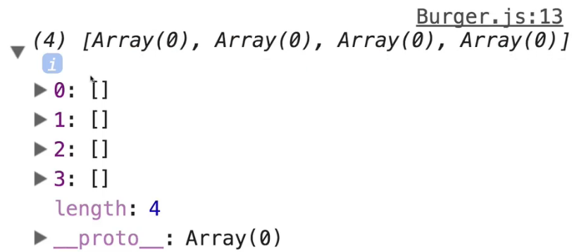  
=> This is what the transformedIngredients looks like now. We can simply flatten this array. And create 1 array only which contains all these values.  
=> We can do that by adding reduce to our transformedIngredients logic here.  
=> **.reduce()** is a built-in array function which allows us to transform an array into something else.  
* It takes a function as input and this function receives 2 arguments - passed in automatically by JavaScsript - the previous value (arr) and the current value (el). The .reduce() method does not only accept this callback here which is executed on every element in this array we return here - it also accepts an initial value, let’s say an empty array, so the initial value of the reduced value. And of course we wanna adjust this reduced value by returning something. And it will then loop through all the elements and simply add them to the initial value step by step. So here we want to return the updated value starting with the initial one is then stored in this first argument which we receive in each loop here. So this `arr` argument is the always updated root array which I want to return in the end. So I will simply concat something to that - .concat(el) - this will simply take the given element for which we’re looping and add it to this array.   
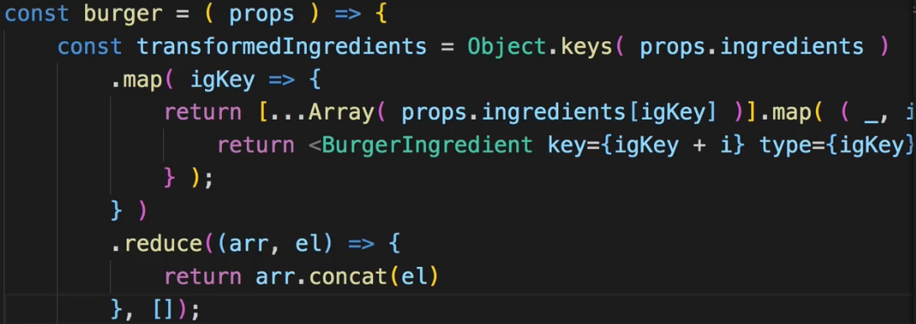  
=> Now we get an empty array.  
  
=> And if we introduce something like 2 cheese pieces, we get an array with 2 objects:  
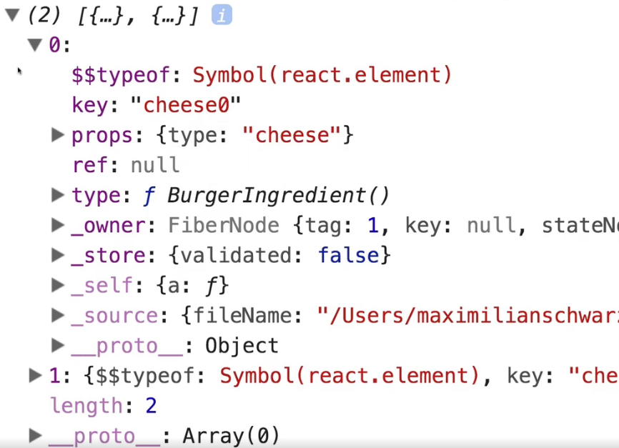  
=> They look strange because they are JSX elements handled by React.  
* Let’s use `let` for the transformedIngredients and do:  
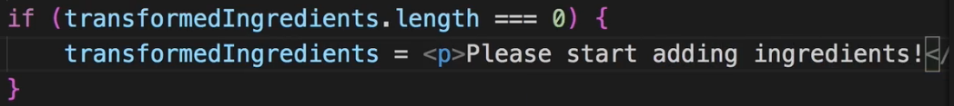  
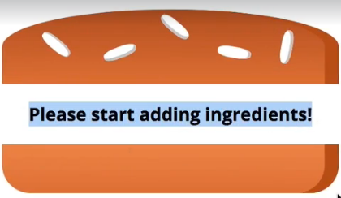  
**Adding the Build Control Component**  
* Adding BuildControls to the Burger folder.  
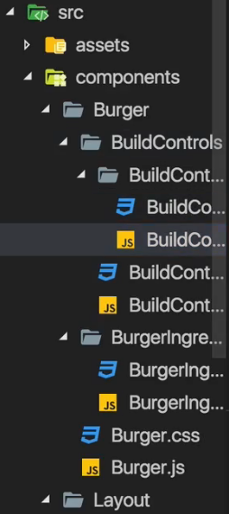 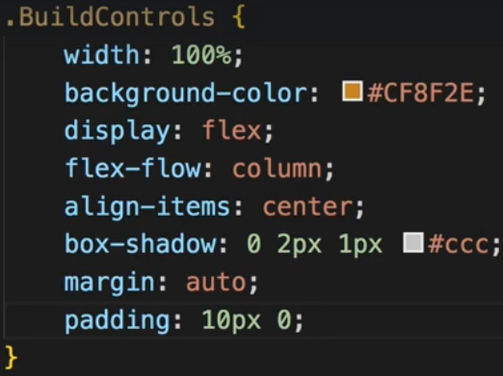  
* In my opinion it makes sense to also outsource these build controls because it’s not just 1 button, it’s a label and then 2 buttons and it’s basically a reusable UI element so putting it into its own component makes a lot of sense.  
* Adding BuildControl inside BuildControls.  
* In BuildControls and BuildControl we use a DIV for styling.  
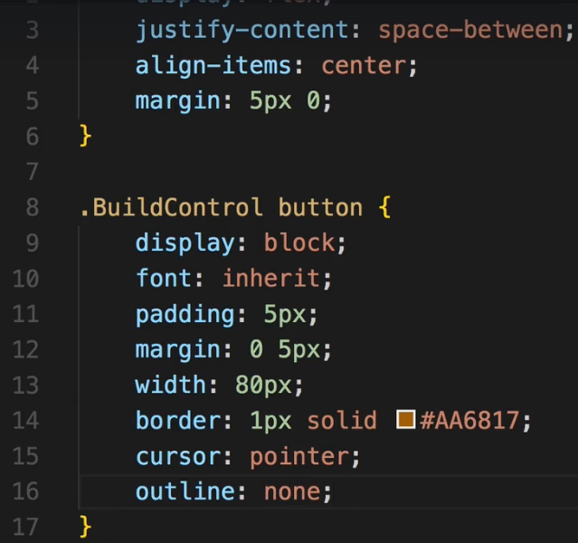  
=> All the other styles are in an attached file you can copy them.  
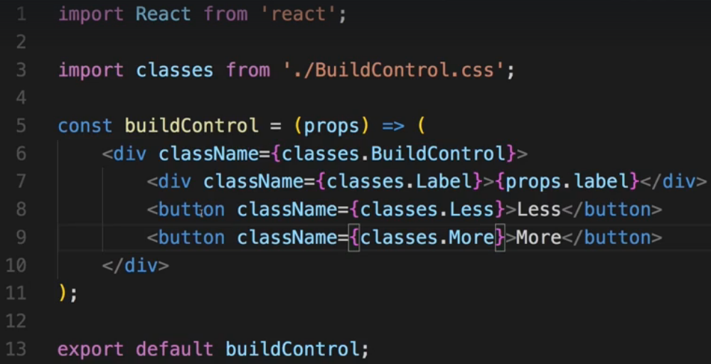  
=> Now a single BuildControl is styled and ready.  
**Outputting Multiple Build Controls**  
* I will create a constant which I won’t export, named controls.  
* And this is optional, you could just hard-code all the controls but I want to have an array through which I can loop to conveniently build all these BuildControls and render them.  
* In BuildControls.js:  
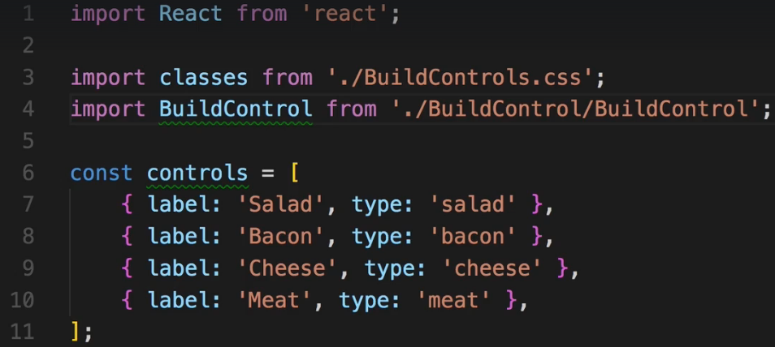  
* Now let’s create a loop with {} to inline it here because it’s really short.  
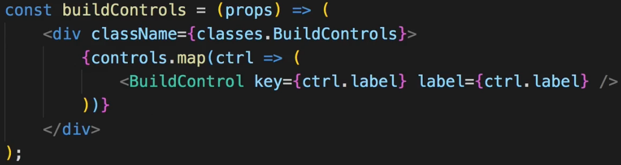  
* Let’s now import it to the BurgerBuilder.js and use it there.  
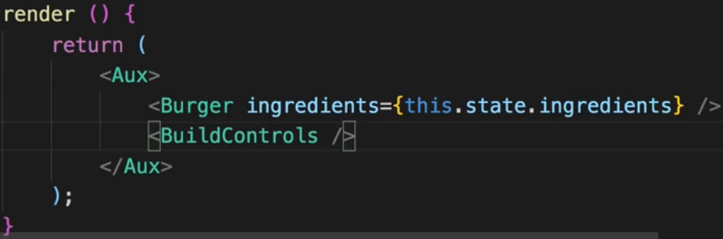  
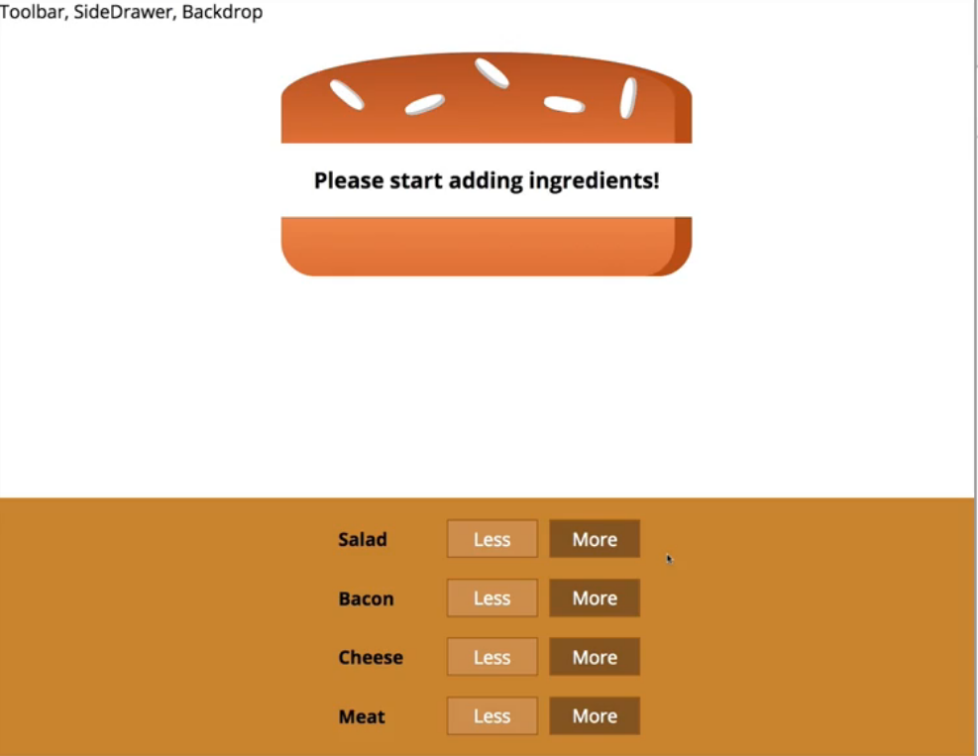  
* The buttons don’t do anything let but we’re very close.  
**Connecting State to Build Controls**  
* To update the ingredients in the state, I will create a new constant updatedIngredients because as you learned, state should be updated in an immutable way.   
* Let’s also keep track of total price in the state.  
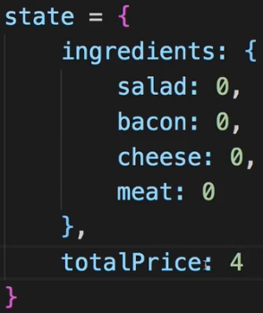  
=> For that we need to have a mapping of which ingredient costs what, for that I will create a new constant outside of the class.  
=> You typically name constants you wanna use as **GLOBAL CONSTANTS** in **ALL CAPITAL**.  
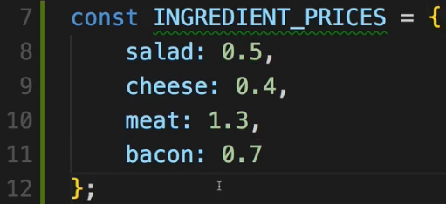  
* You could do these calculations in less lines.  
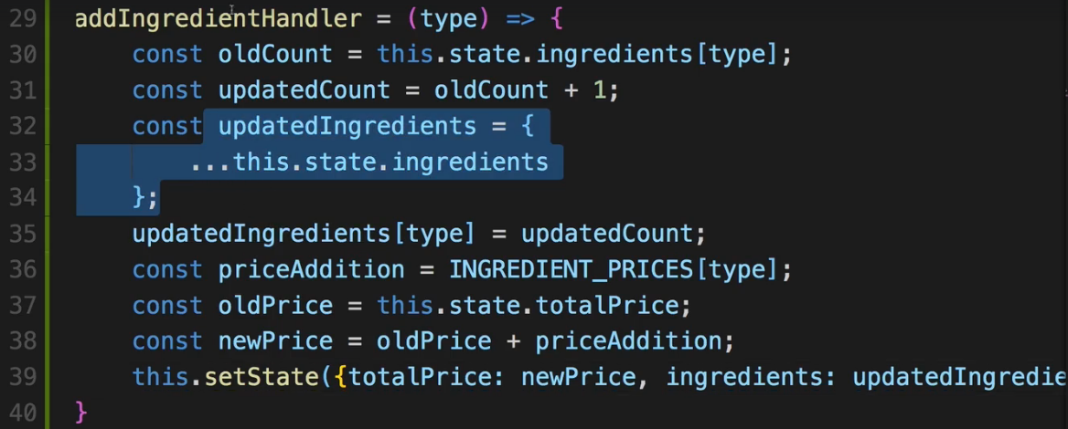

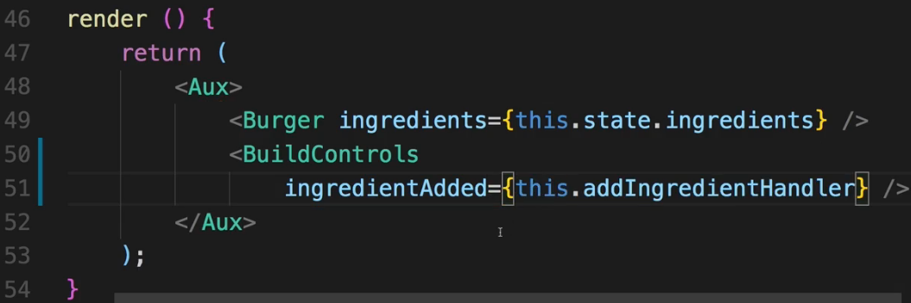  
* Now inside BuildControls.  
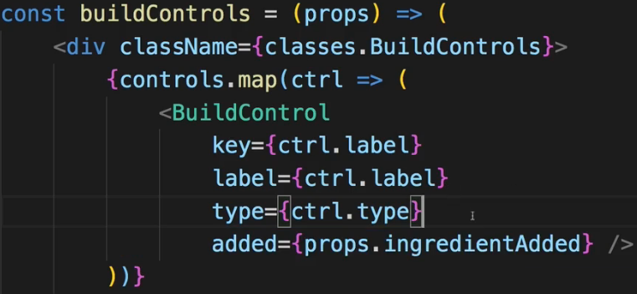 => 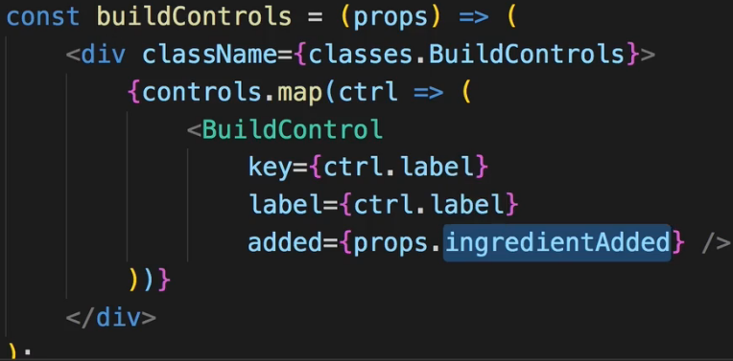  
=> Now with that in here I pass it on to the individual BuildControl so that it can call that. However, I also need to keep track of which type this BuildControl is of so which type this BuildControl has. And we have all the types in the constant above and use it to create all these controls so I can also pass on the types.   
=> Now I could do that but essentially that’s an unnecessary extra loop. I would now implement a click listener in the BuildControl to just return everything back up.  
=> So I can just omit this and instead set up ES6 function here, execute props.ingredientAdded() so the function reference we’re receiving in BuildControls and there simply pass back ctrl.type. Remember I have access to ctrl.type here because we’re inside that loop where we’re looping through all the controls and each control has a type.  
=> Now I’m executing ingredientAdded() which in the end will lead to nothing else than addIngredientHandler being executed and there I expect to get type as an argument.  
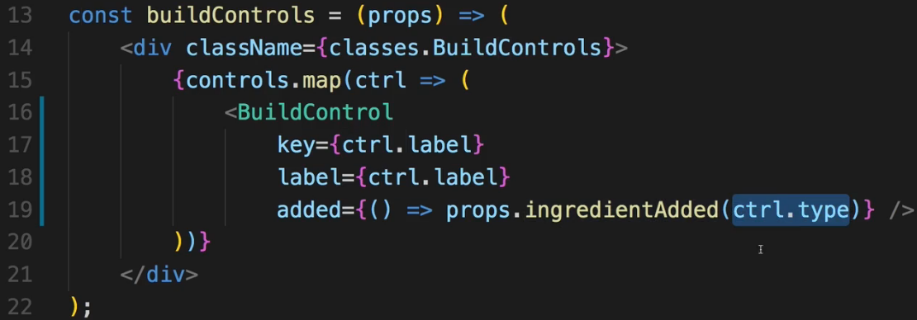  
=> Now of course for this to work, this `added` property which we’re passing to a single BuildControl, needs to be connected to the More button.  
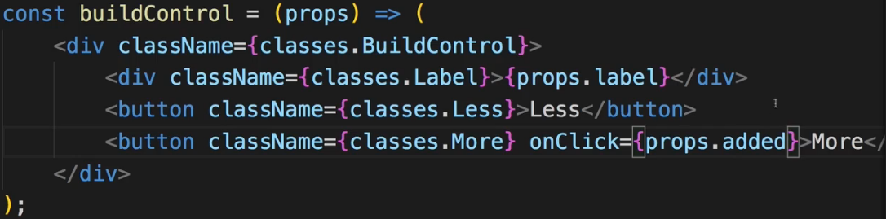  
* Now adding ingredients works perfectly even visually.  
**Removing Ingredients Safely**  
* It’s actually very similar to adding.  
  
  
  
* In BurgerBuilder.js:  
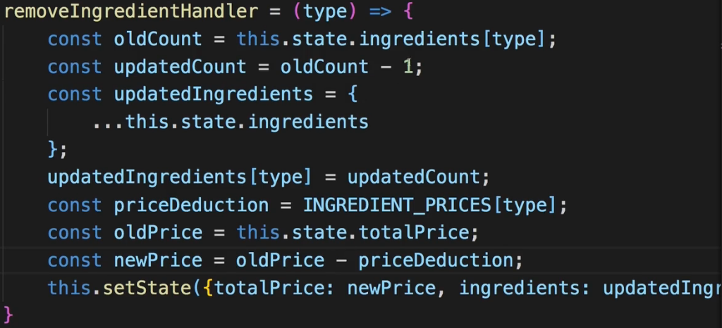  
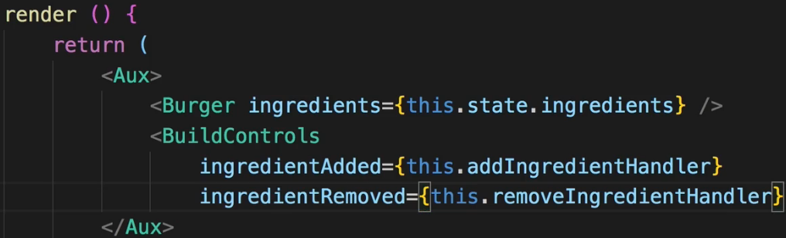  
* In BuildControls.js:  
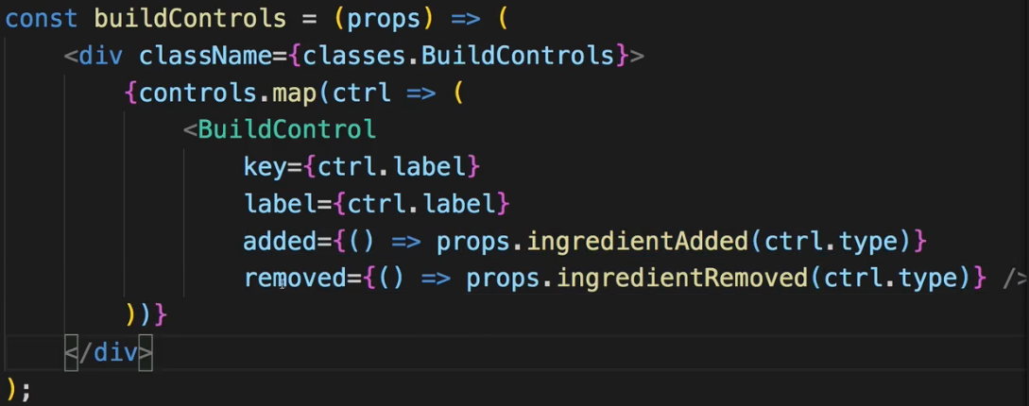  
* In BuildControl.js:  
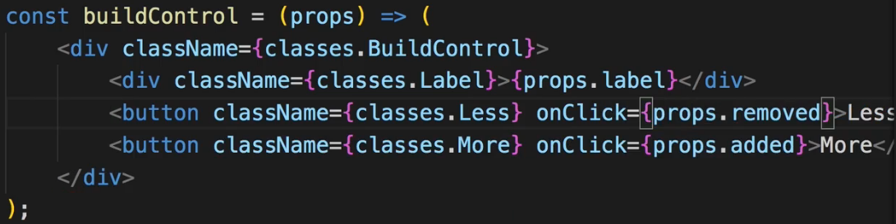  
* Now this removing works.  
* We have a problem when we start removing ingredients that we don’t have though. So the state becomes negative and that throws an erro because we can’t create an array from a negative number.  
=> So in the removeIngredientHandler we should check if we do have the ingredient.   
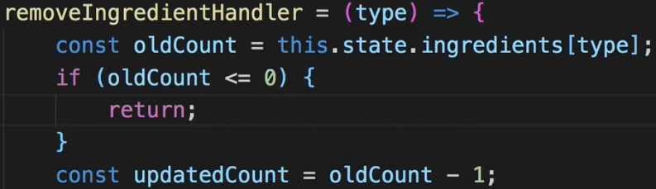  
* Of course it would be even better if the button would be disabled then.  
=> There I want to pass some information about which button should be enabled and which button should be disabled, to my BuildControls.  
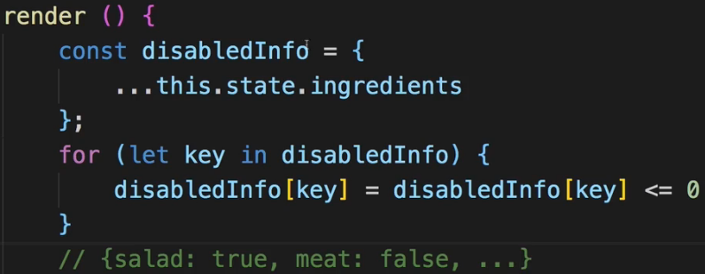  
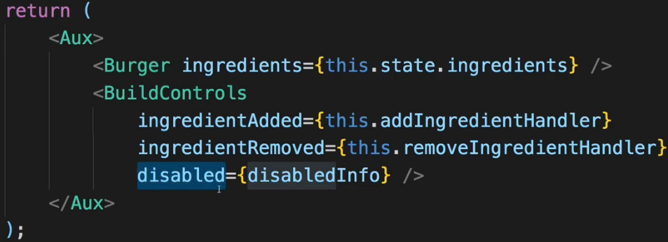  
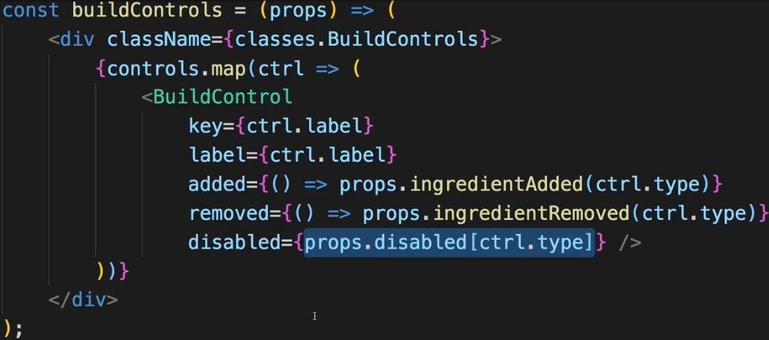  
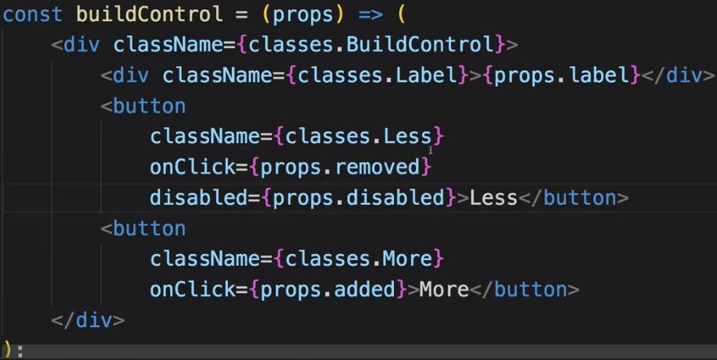  
* The styling is set up to style the button differently when disabled.  
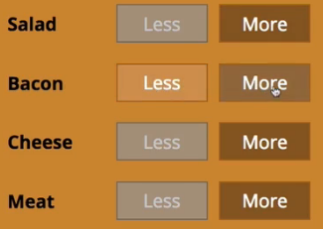  
**Displaying and Updating the Burger Price**  
* Now if I add a lot of ingredients, it is scrollable because we configured it to be scrollable. So the price should probably be displayed above the build controls let’s say.  
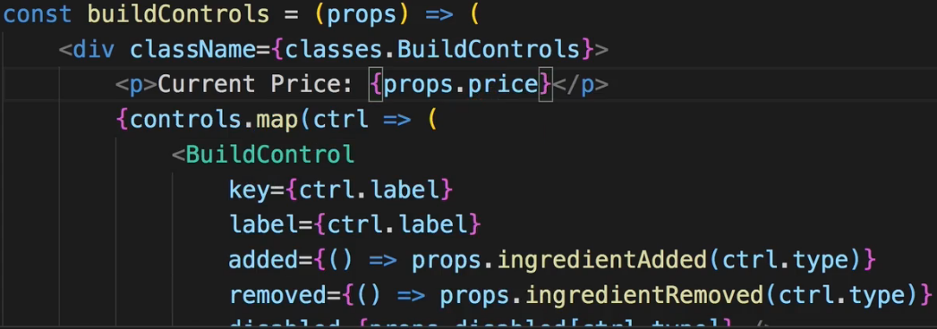  
* In BurgerBuilder.js:  
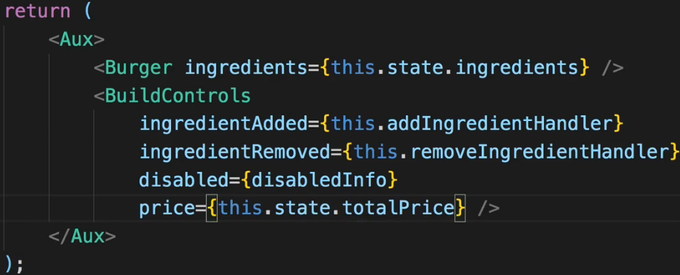

  
=> Here we have a bug with decimal numbers in JavaScript so we should fix this.  
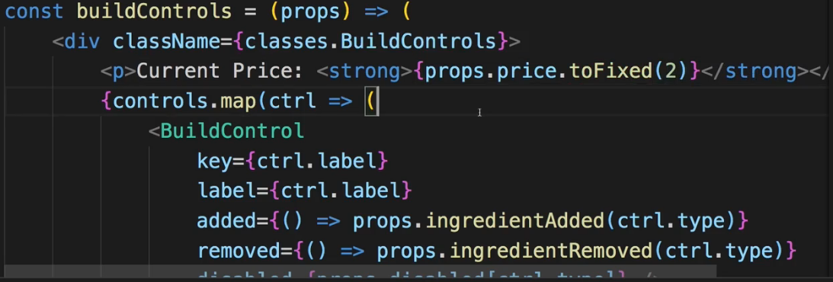  
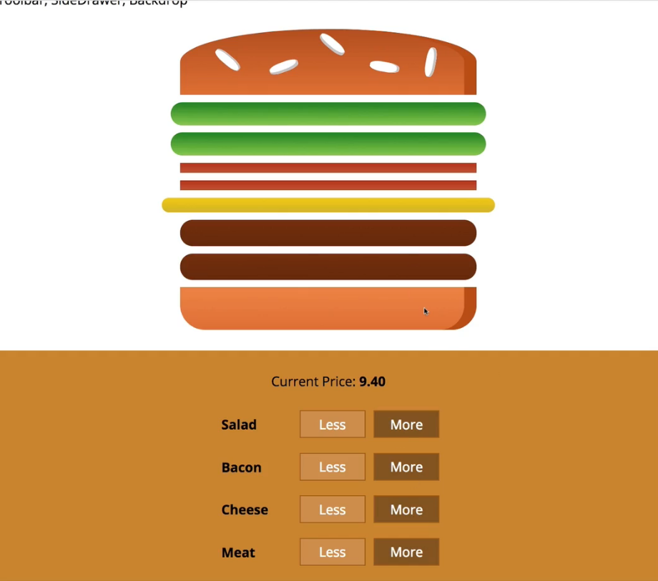  
**Adding the Order Button**  
* Now let’s create the modal which allows us to display order summary. This modal should be shown once we click the checkout button which we also need to add, below our build controls.  
* Copy the styles into BuildControls.css to style the .OrderButton - hover, active, disabled and a little animation which will simply animate the button once it becomes active.  
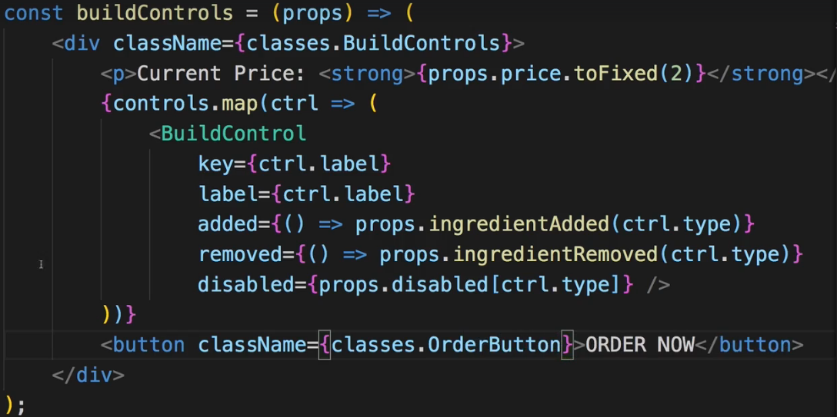 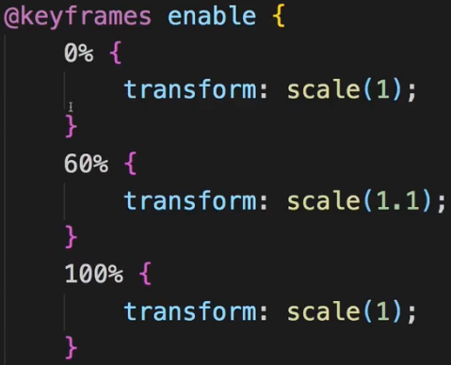  
=> If at least 1 ingredient is at 1, we wanna activate this button.  
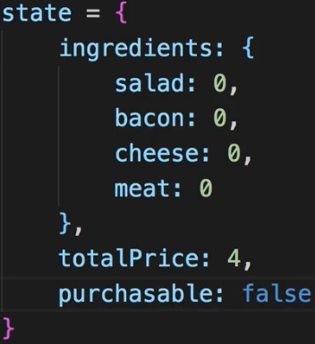

* We also use .reduce(), this time not to flatten the array but to turn it into a single number.  
=> In that function we get the new sum and the individual element. And keep in mind sum simply is the constantly updated current sum up until the current iteration where this function’s executed and once this function was executed on all array elements, sum is the final result. Element is a number because it’s the value we accessed in ingredients[igKey].  
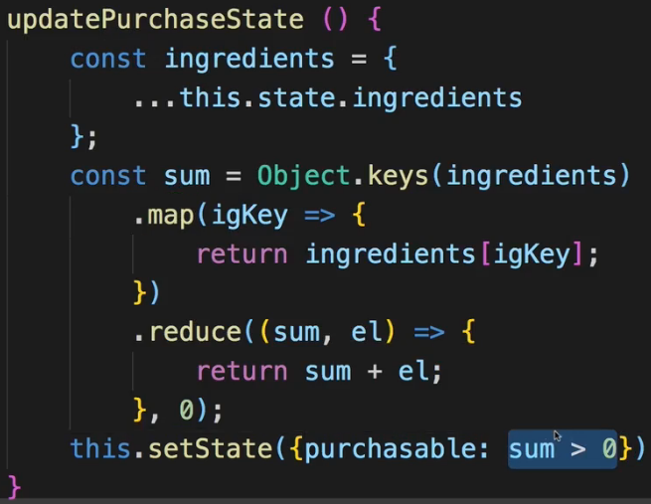  
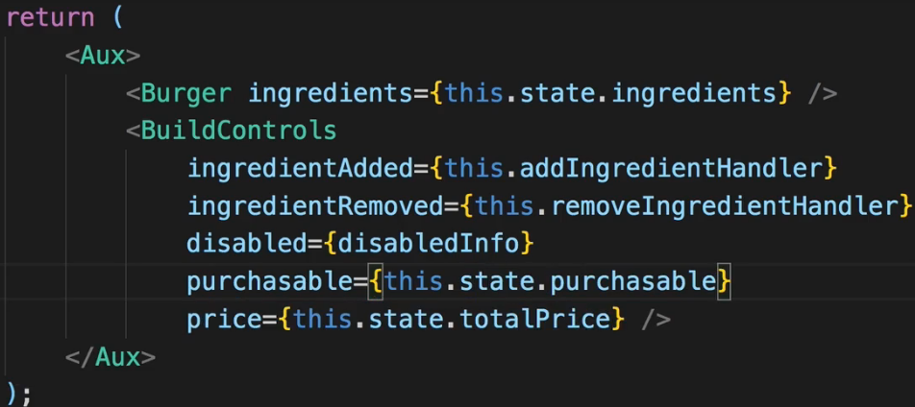  
* In BuildControls.js:  
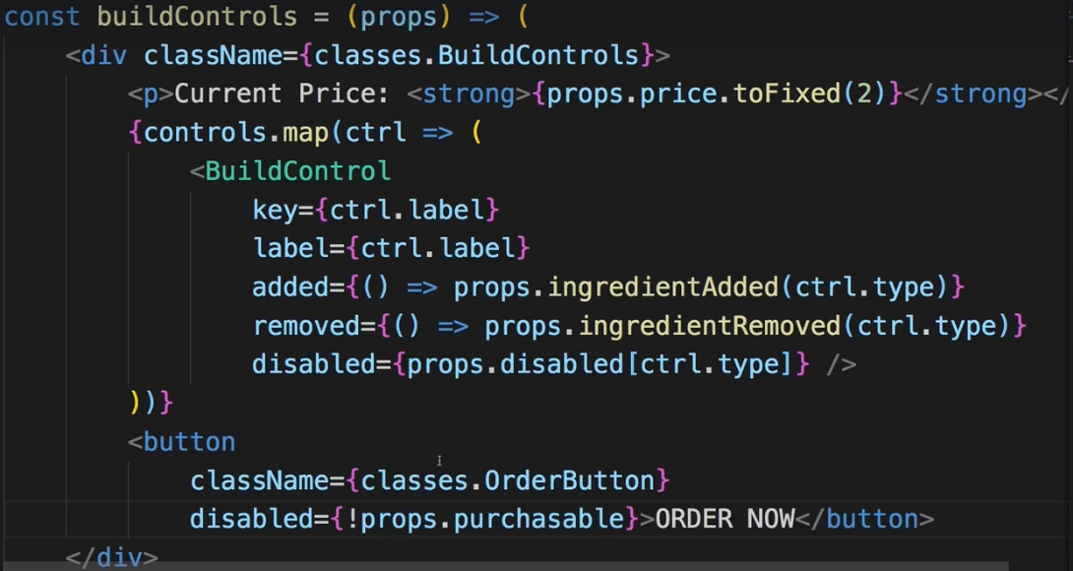  
=> **We should run the updatePurchaseState after addIngredientHandler and removeIngredientHandler**.  
=> **Add it to the end of those methods**.  
* Now if there’s 1 ingredient, it stays disabled, if there are 2, it’s enabled.   
  
=> The problem is that the ingredients which I’m analyzing is of course my old state here.  
=> Now due to the way setState() works, when we execute updatePurchaseState(), we might not get the updated ingredients and therefore once we copy the ingredients and analyze them, we might simply get an outdated version. Now we can of course fix it by passing the updatedIngredients to it.  
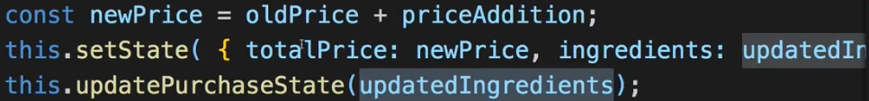  
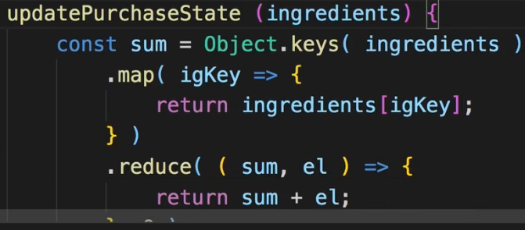  
=> Now we use that instead of the copy from the state.  
**Creating the Order Summary Modal**  
* Now once we click the button we want to open a modal with the order summary.  
* Now for that we obviously need the modal, we need a backdrop and we need to show some order summary.  
* The idea behind the modal is to have a wrapping element which provides the styling which then simply wraps itself around any content we wanna show in that modal. That makes sense to me at least.  
* I’m not adding the Backdrop to the Modal folder because we might reuse the Backdrop in other places too - for example for the SideDrawer for the navigation.  
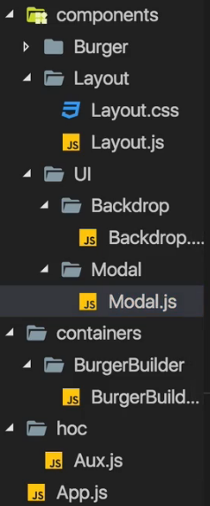 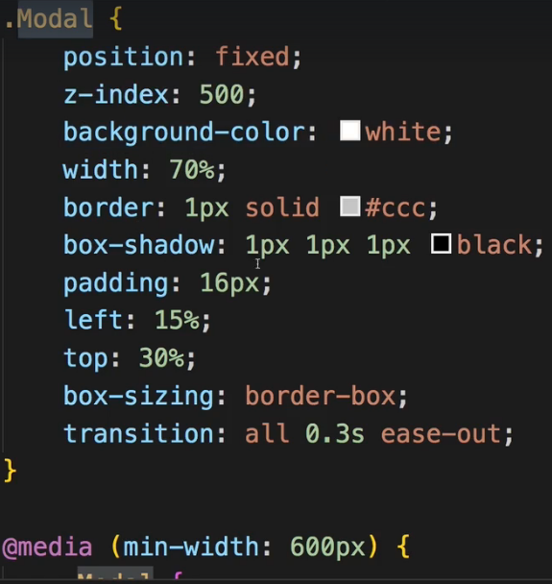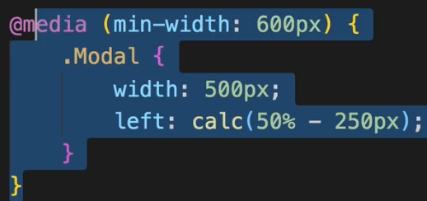  
* The {props.children} really can be anything. Our own components, some text, a paragraph,…  
=> Use the styling in Modal.css that is attached to this video.  
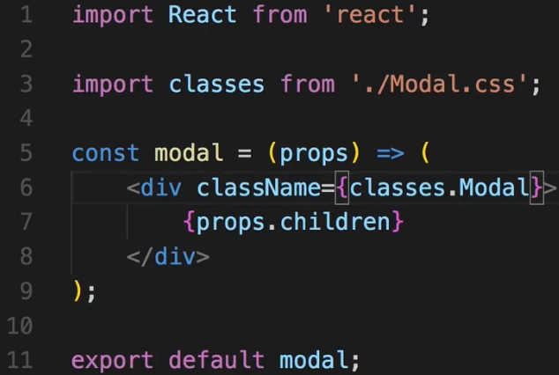  
* The question is - where in the application should we add the modal? Well, I would say we add it in a place we wanna show it because that is the logical place where it belongs and where we probably have the state and the methods to control the display. So in our case that’s the BurgerBuilder.js.  
=> The goal was to show the order summary. And this BurgerBuilder.js file is already getting quite crowded, so I don’t wanna add the logic to transform this ingredients array into a nicely structured summary into this file. I will outsource it into its own component as this is generally a good practice in React - have granular focused components.  
* It makes sense to add this on the same level as BuildControls and BurgerIngredients I guess.   
* I don’t really need a wrapping DIV here so I’ll import my **Aux** --- or use **FRAGMENTS <> </>**.  
* In the <ul> I could hard-code it but I want to create this dynamically because we’re always dynamic in React.  
* The ingredients are again in the object format and not an array. Now of course we could also create this component in a way to expect an array and transform the array in the BurgerBuilder where we will then pass it on toward the summary. But you can also do it the other way around and simply pass the object on and do the transformation in orderSummary - it’s the approach I’ll follow because I believe that this allows us to keep the burger folder a bit leaner though you could argue for both directions where this should happen.  
* Now when hard-coding this it would of course be easier because I could just hard-code 4 list items and access the respective property on the ingredients object but I want to create it a bit more flexible way.  
* We use <span> to have the ingredients with a capital letter. We use inline styling.  
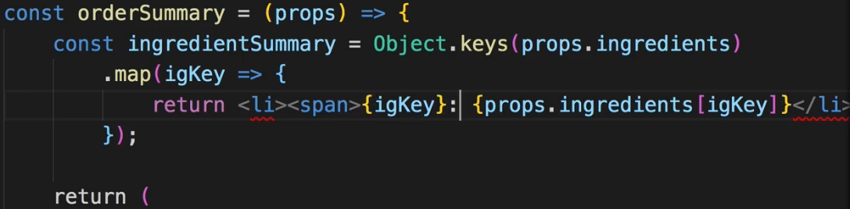  
  
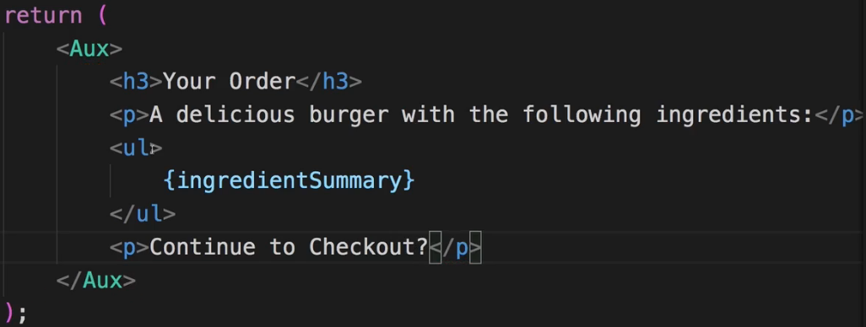  
* I won’t style this <ul> because here for this rare occasion I’ll actually use the default style of all these elements. Which is why the OrderSummary.js component doesn’t even have its own OrderSummary.css file. Though of course you are free to add one and style it.  
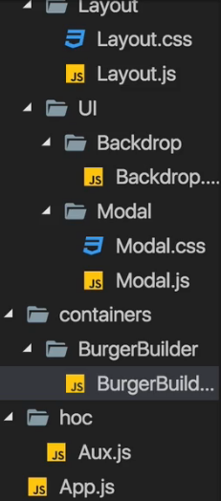

* Now in BurgerBuilder.js:  
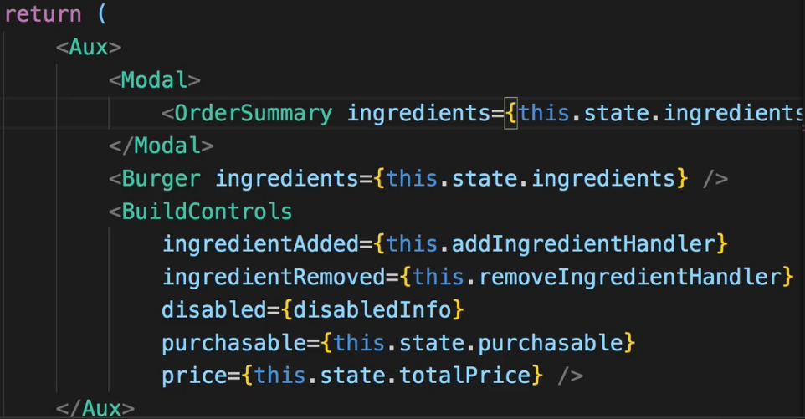  
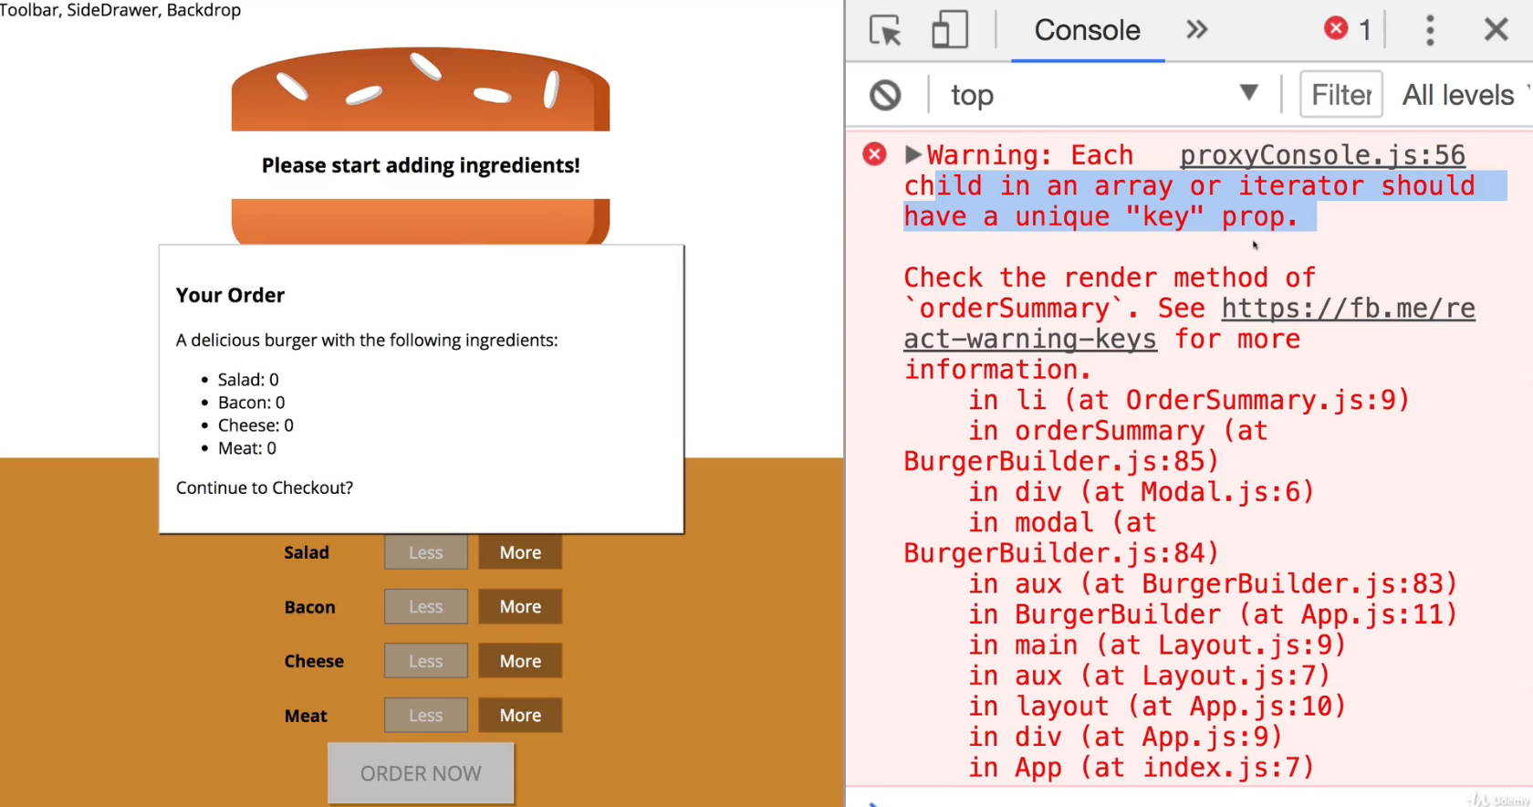  
=> We forgot to add the key to our array but generally this looks good.  
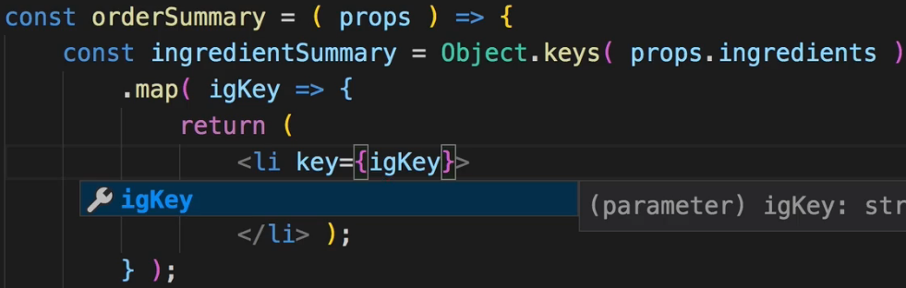  
**Showing & Hiding the Modal (with Animation!)**  
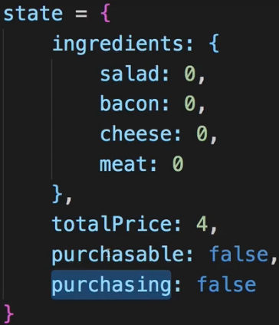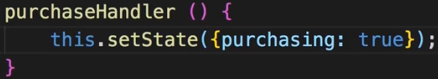  
* In BuildControls.js:  
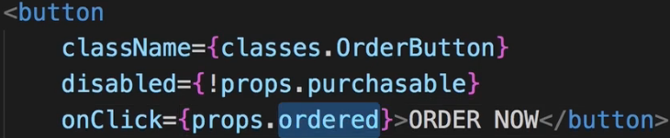  
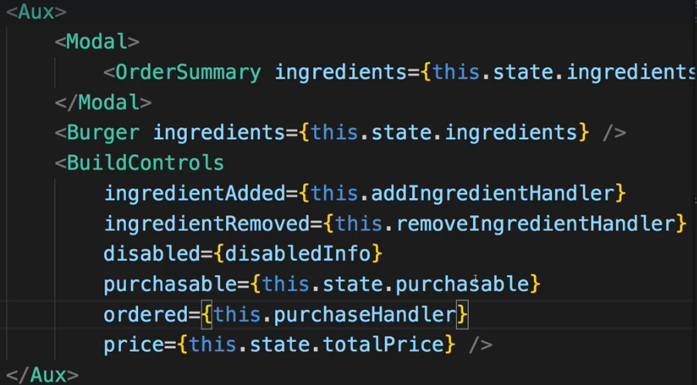  
* Now we could add some code to conditionally show or hide the Modal, this would certainly be a way.  
* Would be even nicer if we could play a tiny animation on the modal.  
* We already prepared for it in the CSS file:  
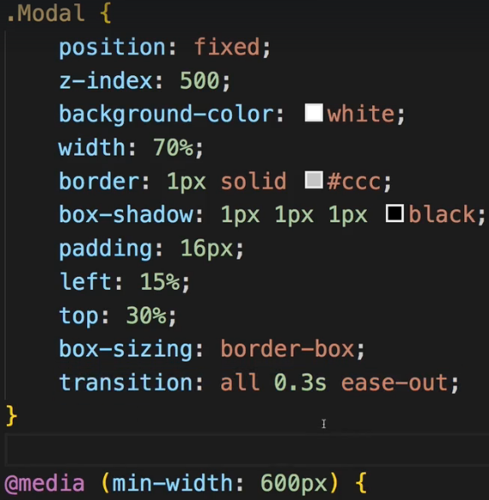  
* If we just add/remove the modal from/to the DOM, we won’t see the animation, we need to switch some CSS property to show or hide it, to be able to animate that.  
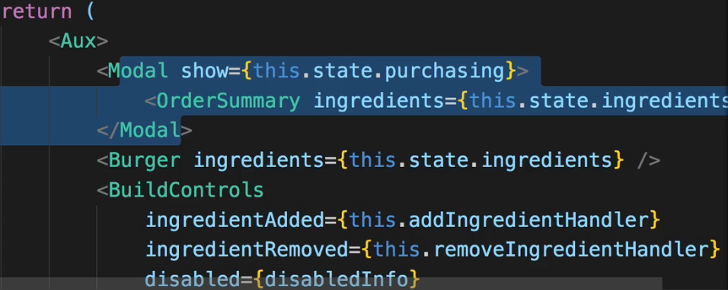  
* Now we wanna change some inline style, though you could also add a new CSS class and add this class conditionally as we do it in other places of this application already, but to also practice some inline styles, let’s use that.  
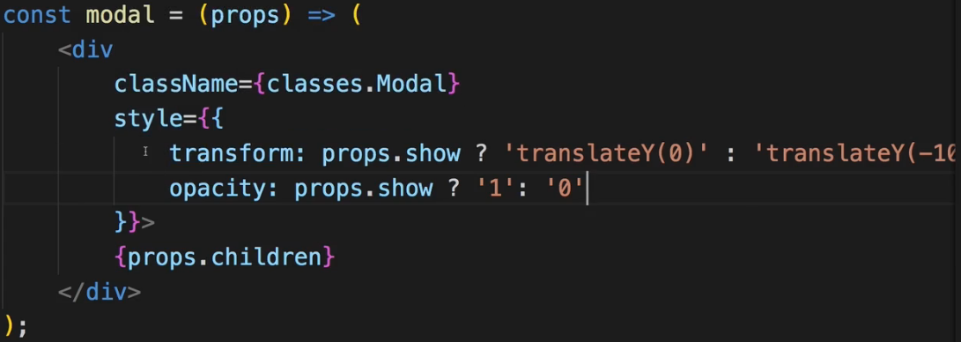  
* **Now this.setState() fails and throws an error - why?**  
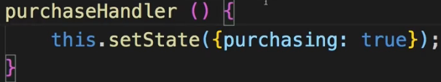=> It fails because of the way I’m creating this method. I use the same syntax as I use for render(). But earlier in the course I mentioned that that this syntax will not work correctly --- at least if we try to use the `this` keyword in there, if the method is triggered through an event. Due to the way `this` keyword works in JavaScript it will then not refer to the class. In the add/remove methods I use the ES6 arrow functions. In the end these are still methods but internally they take advantage of arrow functions which basically contain the state or the context of `this`.  
=> So we can easily fix it by using an arrow function:  
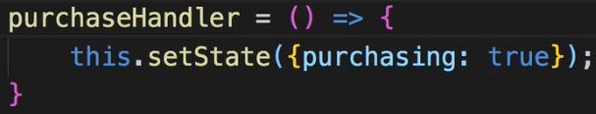  
* Now it would be good if we also had a Backdrop and if we clicked that Backdrop, it would then dismiss the modal.  
**Implementing the Backdrop Component**  
* You can return `**null**` in components.  
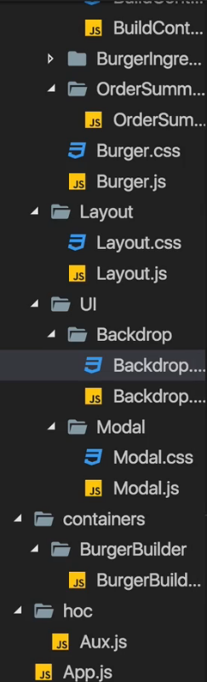 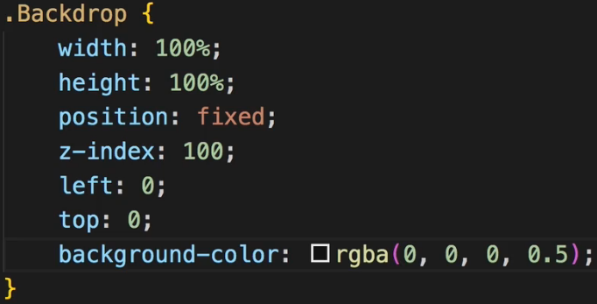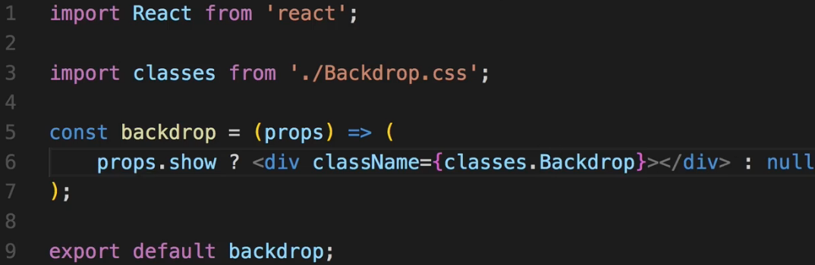  
* The .Modal has a z-index: 500, that’s important. We use z-index: 100 in the Backdrop.  
* The question is where do we add this Backdrop. Now there are multiple places where you could argue that it makes sense.  
=> One such place would be in the App.js component. Have it sit next to the Layout - outside of the Layout because it’s not part of the core page content.  
=> OR have it sit in the Layout.js component because it is part of the page but it should not be part of the main content and not be part of the toolbar or anything like that. You can definitely do that, you just need to make sure that you can then reach that by passing the -show the backdrop state- up to that component and so on. You might need to switch some Stateless components to Stateful components because maybe all of a sudden you need to define some method in a component.  
=> **I will go for another approach though - I will add the Backdrop to my Modal**.  
=> Because in my opinion, this Backdrop is closely connected to the Modal - if the Modal is shown, the Backdrop should be shown.

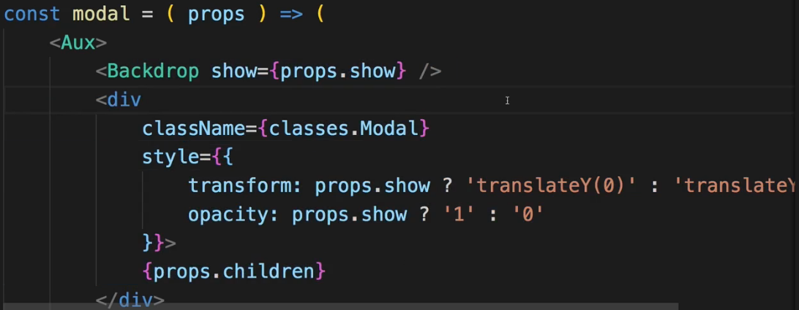  
* Let’s now make sure we can click this Backdrop too. For that we need to add a click listener inside the Backdrop on the DIV.  
  
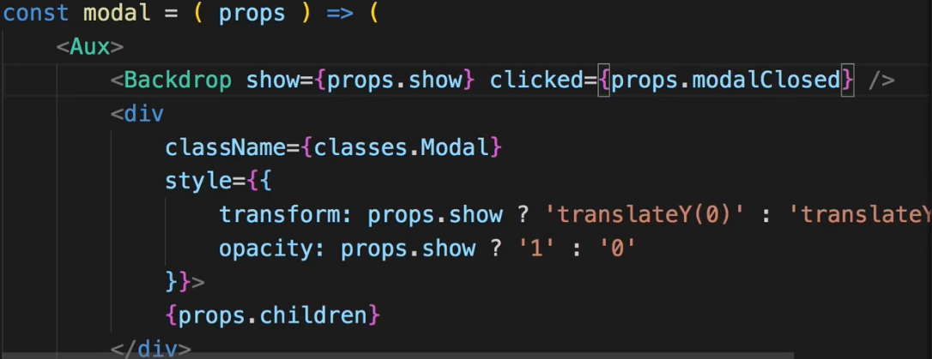  
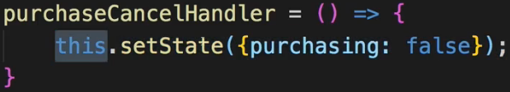 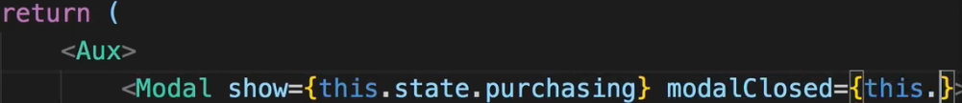  
**Adding a Custom Button Component**  
* We get a CANCEL and CONTINUE buttons in OrderSummary.js.  
* CANCEL will essentially do the same as clicking on the Backdrop does.  
* And actually I might reuse certain button styles throughout the application.  
* Having a CANCEL and CONTINUE button makes a lot of sense so maybe we should outsource the button into its own component even though there already is a button element in HTML, we might still put it into its own component so that we can wrap it with some default styling don’t have to style the button in any component where we use it, from scratch again.  
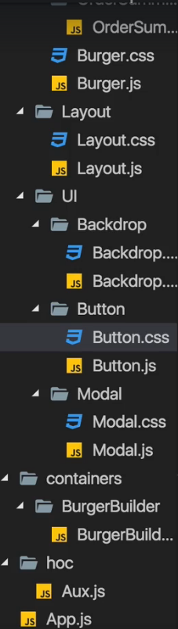  
* Again we attach a CSS file.  
* We always want to assign the .Button class and then conditionally we want to assign the .Success or .Danger class.  
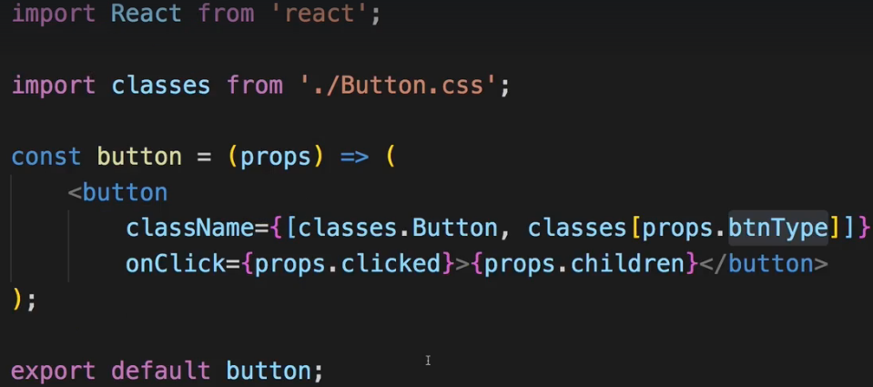  
* And of course you could also use a different approach of assigning the classes, I like this one because it’s really flexible and easy to implement.  
* Keep in mind that what we pass in className has to be a string, right now it’s an array of strings though.  
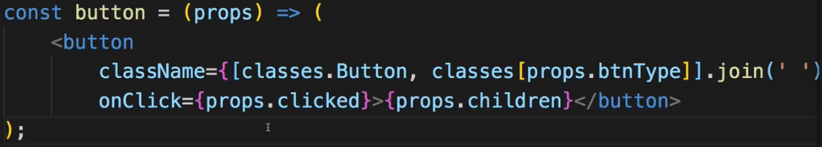  
**Implementing the Button Component**  
* In BurgerBuilder.js: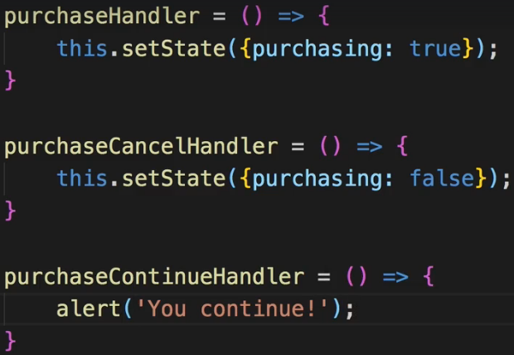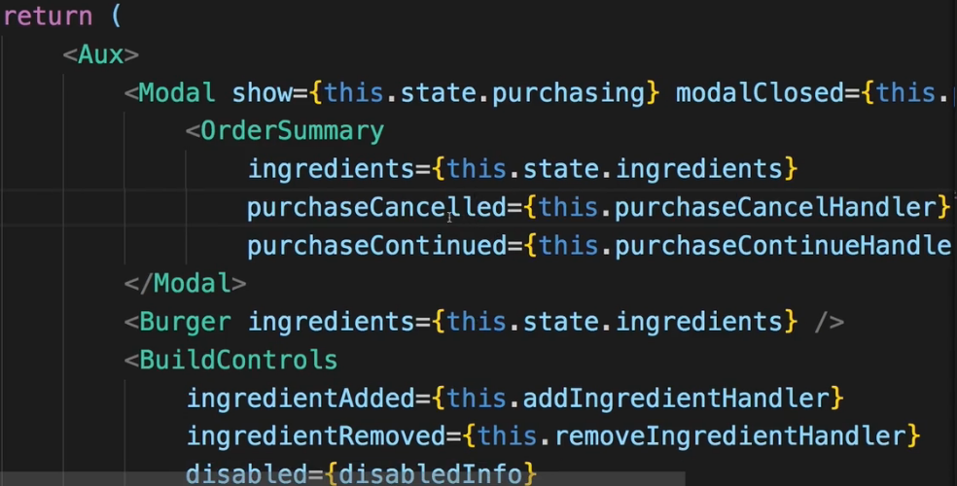  
* In OrderSummary.js:  
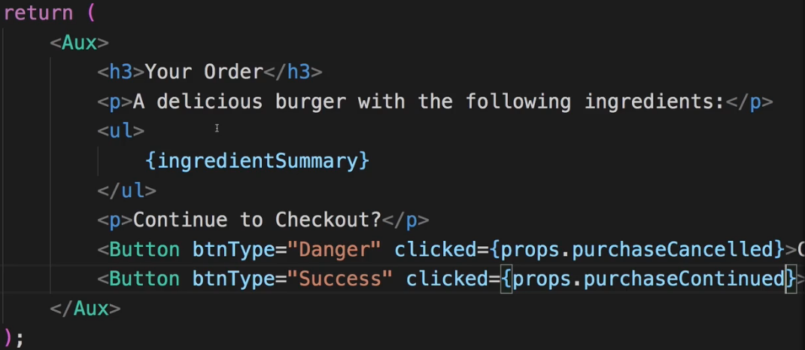

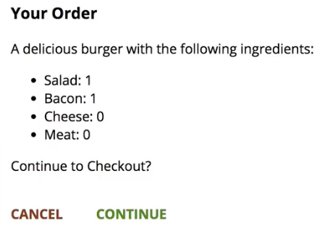  
=> This is the Modal.  
=> And this is the Burger Builder as far as we can build it from a Build the Burger side.  
=> Later we’ll also add functionality to really kind of make the purchase and store that in a database on a real server where we then probably would process the order if it were a real app. And we’ll also add more pages so that the user can also see a page of the orders he placed. And of course we’ll also overhaul this app with Redux  
* We’re not done yet though - what’s missing?  
=> Toolbar, SideDrawer, and the Backdrop for this SideDrawer. Well at least we got that Backdrop.  
**Adding the Price to the Order Summary**  
* I just noticed that if we order the burger, we don’t see the total sum in the OrderSummary.  
* In OrderSummary.js.  
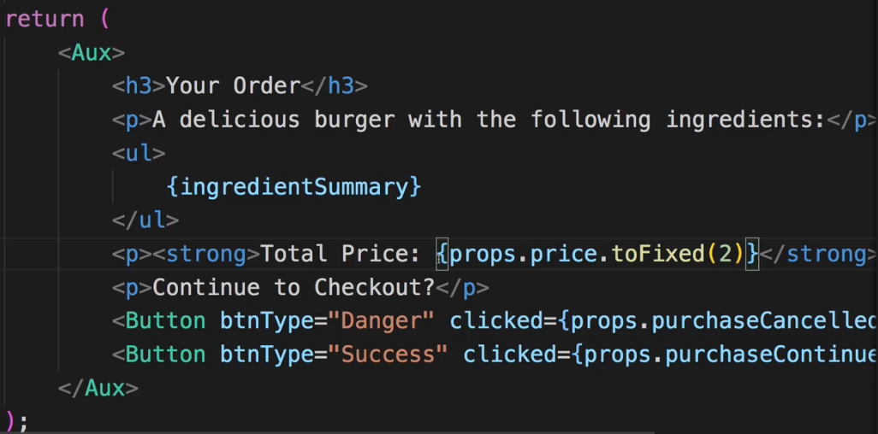  
* In BurgerBuilder.js.  
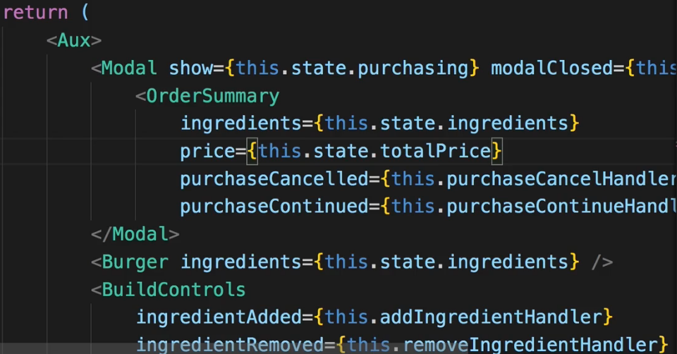  
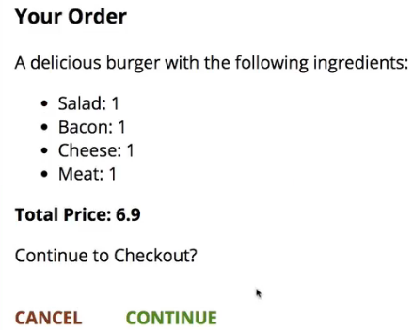

**Adding a Toolbar**  
* Every application should probably have a Toolbar, it makes it look better.  
* I want to have a wrapping <header> element because the Toolbar is the header of my Web Application.  
=> Now inside, I want to have some button which opens the SideDrawer. For now we have this DIV containing MENU placeholder though.  
=> Then I also want to have a DIV which contains my LOGO and we’ll have to add this.  
=> And thereafter I want to have a NAV item which contains my navigation links. So basically this will contain some UL with all the links, I’ll just leave the … palceholder.  
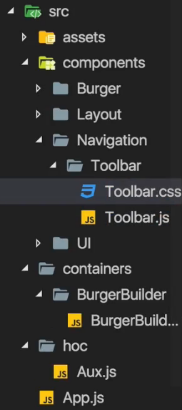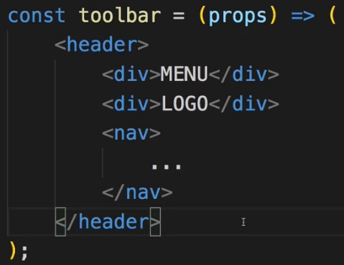  
=> All these 3 could be components which we could reuse.  
* Our CSS is mobile-first. For Toolbar, most settings should work for both mobile and desktop which is why we start with the Toolbar.  
* We use z-index: 90, this has to be lower than the z-index for the Backdrop, where we have 100 because the Backdrop should go above the Toolbar.  
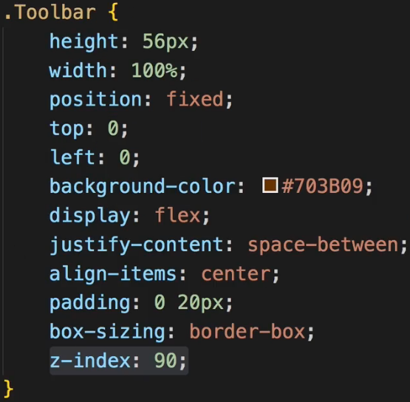 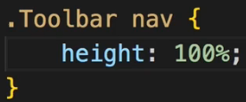  
* Now I want to control how the NAV item is displayed when nested inside a .Toolbar.  
* There I want to set a height of 100% too so that in the navigation I can then also control the height, relative to the Toolbar height and can make sure that the navigation items span full height of this Toolbar.  
* Now where should be add this Toolbar?  
=> You could argue that you want to add it in the BurgerBuilder because that is where we want to have a Toolbar at the top but in the end we want to have a toolbar at the top of any page we load. Therefore we could use the App.js file but the best place, of course, is our Layout. This in the end is about laying out our page. And this is where we already added some placeholders for the toolbar.  
* In Layout.js:  
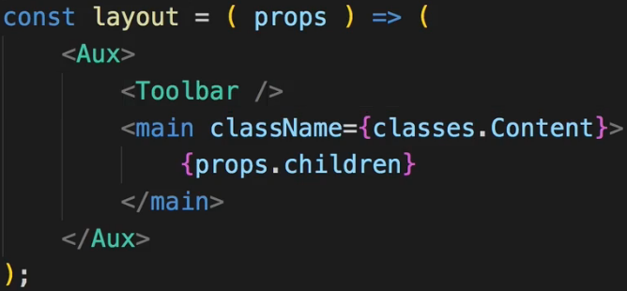  
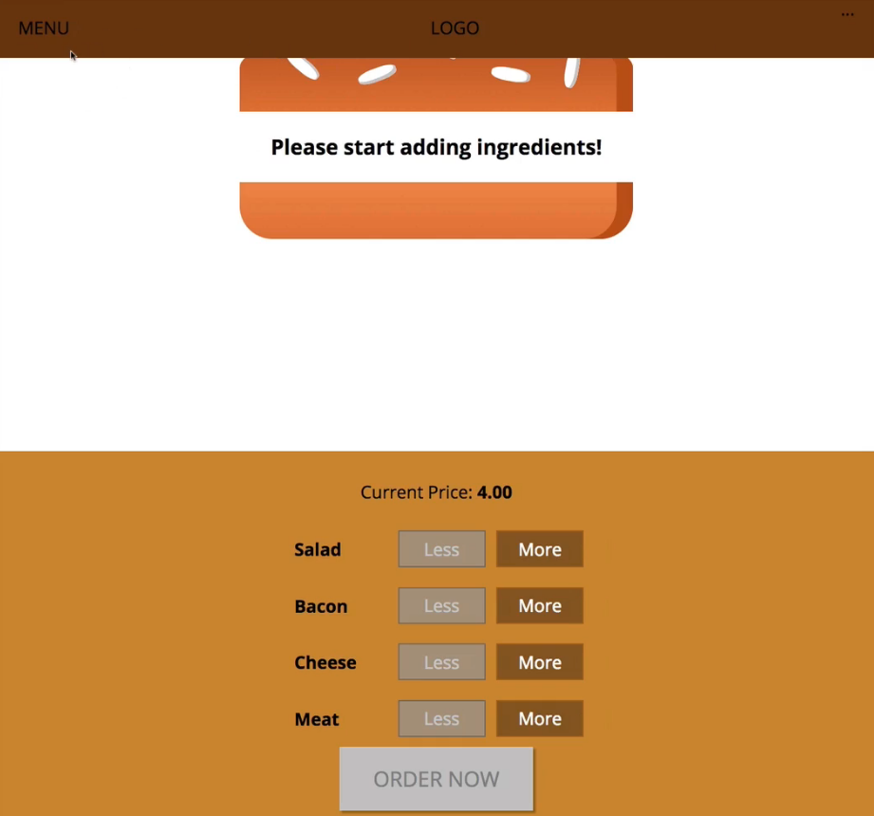  
* Now the text should probably be white. But we’re going to replace all these things with some real content later anyways.  
* We can also notice that our main page here is overlapped by the Toolbar.   
* So that <main> element here which has margin-top: 16px, should probably add these 16px to the Toolbar height of 56px which we set up.  
=> In Layout.css we want to change margin-top: 16px to +56px so 72px.  
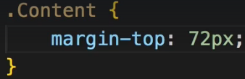  
* Now the burger is nicely positioned again. Now let’s work on the logo.  
**Using a Logo in our Application**  
* I’m not going to add the logo to Navigation, I’m going to add it to components because theoretically we could use the logo anywhere in our application.  
* Now I actually want to use an img file as a logo.  
=> So I’m going to store that image file in the `assets` folder and create `images` sub-folder.  
* It’s a burger with a transparent background.  
=> Now I want to simply display the image in Logo.js, I also want to wrap it in a DIV which sets the background for the image though, because the image itself has a transparent background and I want ot set a white one here.  
* And of course we could even go so far to accept the background color via props and change it dynamically if we wanted to.   
* Now the `src` on the `img` should actually be set dynamically. You could think that you simply say go up to the assets folder > images > burger-logo.png. Now this will not work as you would expect it to work due to the way our build workflow is set up. Keep in mind the `src` folder is only the folder we’re working in, in the end webpack will take all these files, bundle them together and create a new output folder. We can’t see that here because we’re in development mode where all of that will happen in memory but once we do publish our app, we will get a real different folder where all the optimized, compiled and bundled assets are contained in.   
=> **Now therefore this assets folder in the `src` folder will not be shipped to any real server. The whole `src` folder won’t be shipped there. Hence we should also make webpack aware of the fact that we’re using this image and we’re actually doing that by importing the image into our JavaScript file**.   
* Now of course, just like for the CSS files - this does not mean that webpack mixes the image with our JavaScript code. It just means we make webpack aware of the fact that we’re using this image and webpack will then handle this image with a special module that was added to webpack to its config. We’ll basically copy the image over to the destination directory it creates - again only in memory during development. And will even optimize the image.  
* And burgerLogo here will in the end just receive the path of the image where webpack will copy it to.  
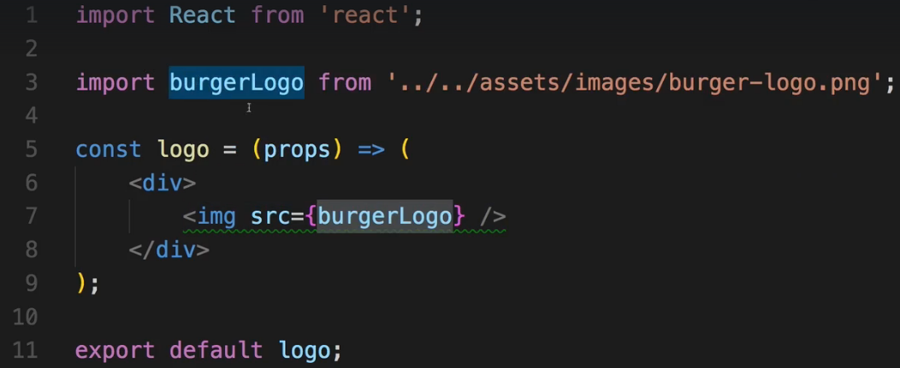  
* And this src={burgerLogo} will again refer to a string in the end, to the path where webpack stored the optimized and copied image. This is important to understand.  
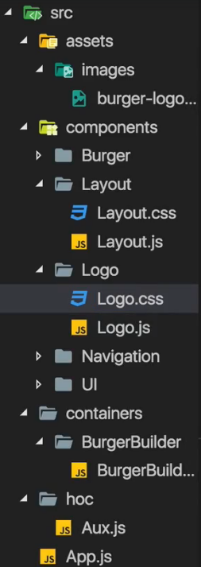 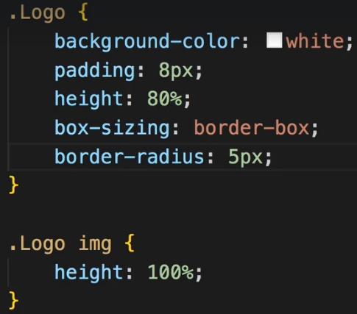  
* And now important - let’s set the image height: 100% so that the image does take this height at a maximum and it does not take its default inherent height which would be higher.  
* We adjust the .Logo height to be 80% so that there is some brown around it on top/bottom.  
* Let’s also set the box-sixing: border-box so that the 80% height also includes the padding.  
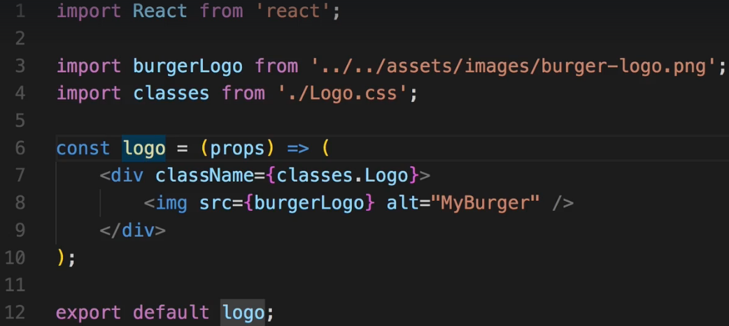

* Now I’ll go to the Toolbar.js because that’s where I want to use the Logo.  
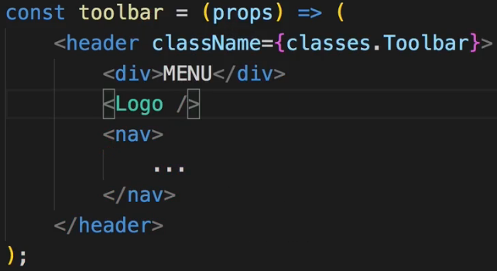  
* Now I can already say we will have to touch the styling for the Logo later on again when we start implementing this in the SideDrawer. But for the Toolbar, this should actually do it.  
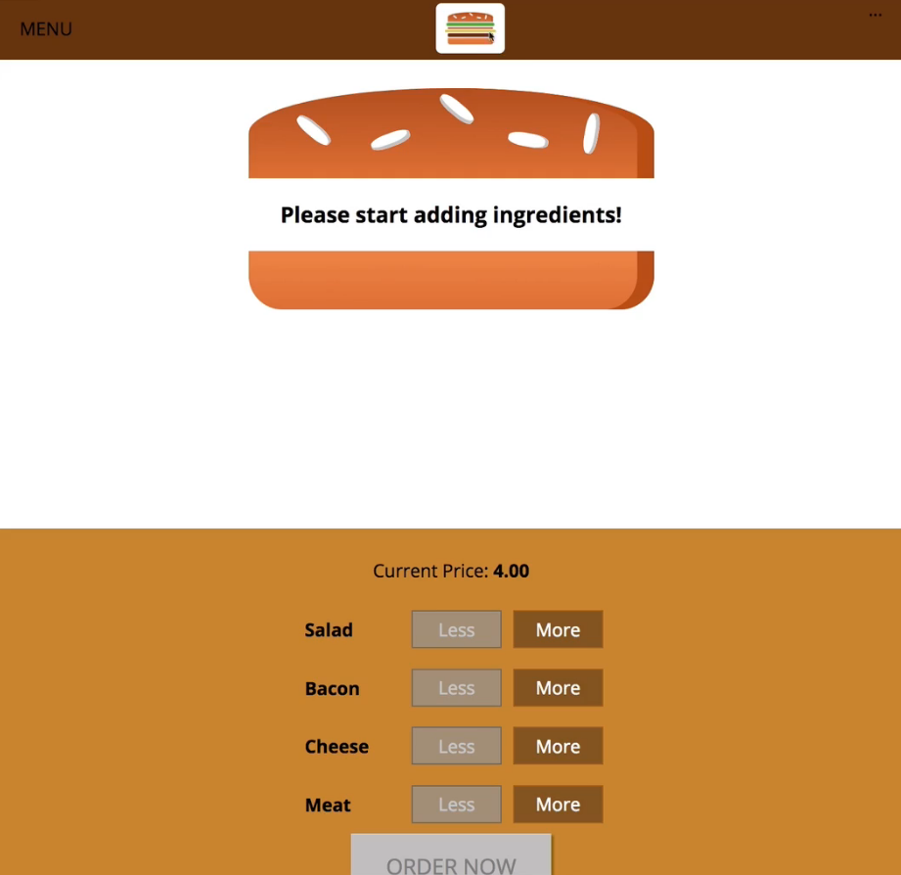  
**Adding Reusable Navigation Items**  
* Let’s outsource the navigation items into their own component becase I actually want to reuse the navigation items in the SideDrawer later on.  
=> Creating a `NavigationItems` folder in the `Navigation` folder.  
* I don’t even need the props there so I don’t need to have them in the component.  
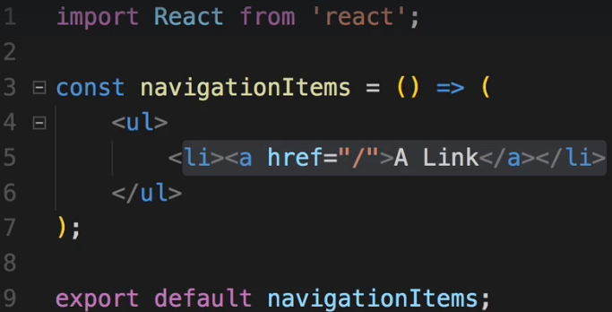  
* We can even go as far as outsourcing the single links into their own components. You could also argue for having only 1 component - the NavigationItems component which holds both the list and the individual items, but since I will add quite some styling to the individual list items, I will outsource it.  
=> Creating a `NavigationItem` folder in the `NavigationItems` folder.

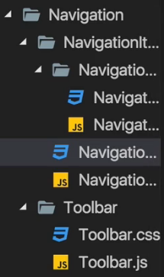 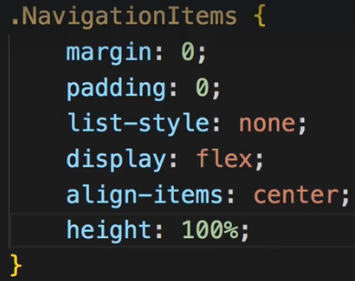  
* Now I’m actually not developing the .NavigationItems mobile-first because we don’t have the SideDrawer yet and we can’t see that and we can’t see that in SideDrawer yet for that reason.  
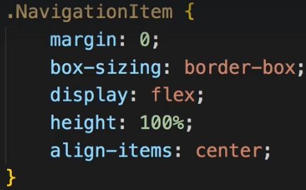 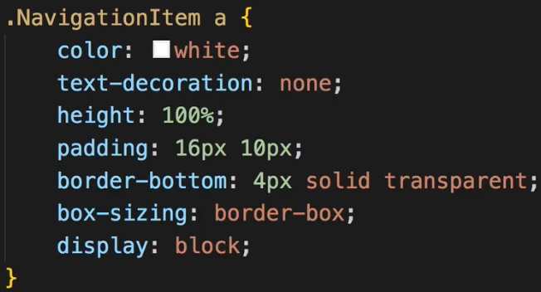 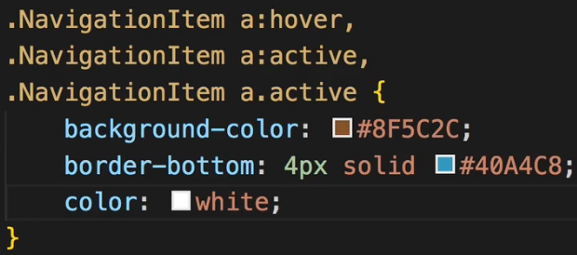  
* We need to add display:flex to make sure that I can center the link vertically, the link inside the list item. I’ll set the height: 100% because I have a special idea about how I want to have active links look.  
* The border will be invisible but this border will become important once we actually highlight a link, once we hover over it.  
* Now let’s style links which are hovered, links which are active = which are clicked on and links which have the .active class - a class I later want to assign to links on which page we are.   
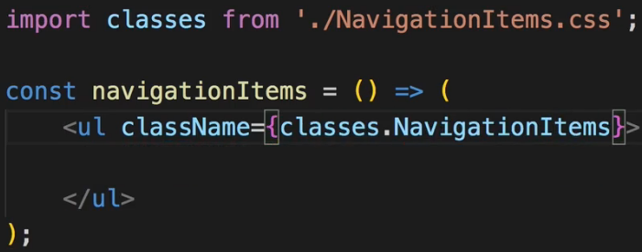 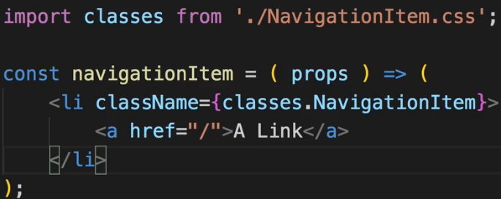  
* Now we wouldn’t see anything because right now we’re not including any NavigationItem-s in our NavigationItems component.  
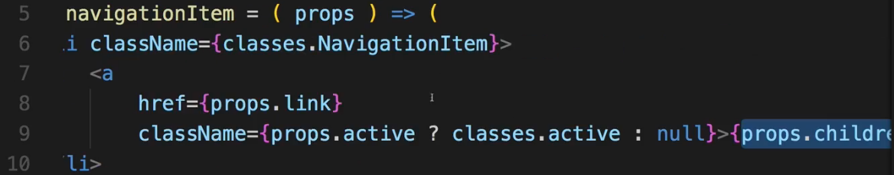  
* Now we could use `**active={true}**` but for boolean props we can just pass it like this `**active**`.  
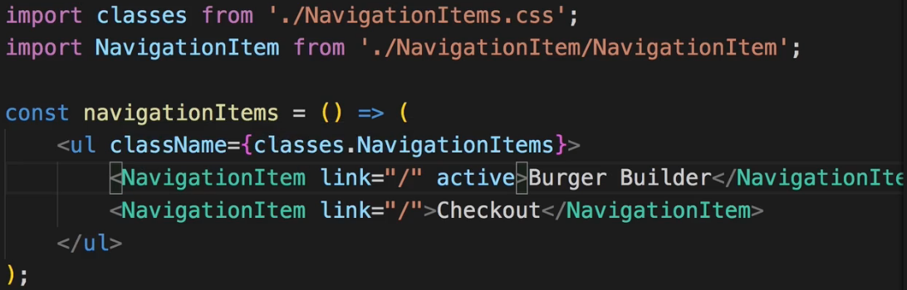  
* Now we have our NavigationItem/s set up, now we need to use our NavigationItems component in the Toolbar.js.  
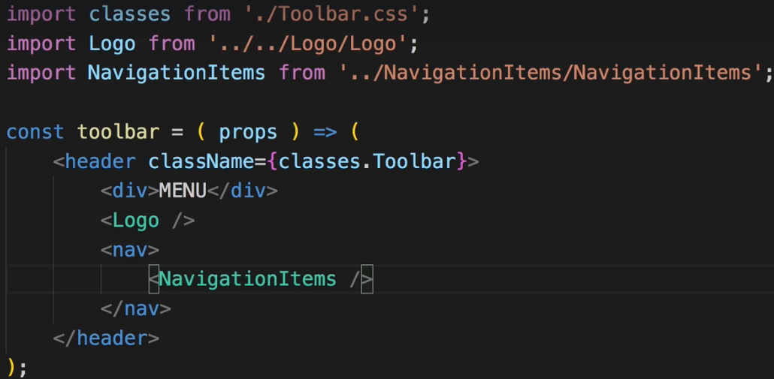  
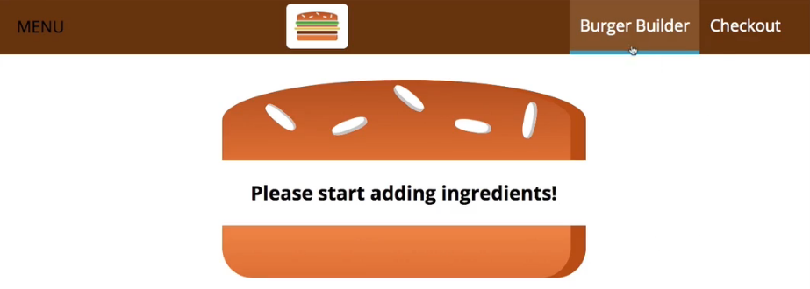  
* Now again this will have to be adjusted once we add the SideDrawer and add mobile navigation but for now it looks great. Let’s have a look at the mobile navigation next.  
**Creating a Responsive SideDrawer**  
* The SideDrawer will consist of 2 components.   
=> The SideDrawer itself and the Toggle button which right now is the placeholder with “MENU”.  
* We might reusa such a button so it should probably go into its own component.  
* Also we’ll need a Backdropfor the SideDrawer but we already got one.  
* We won’t return JSX code immediatelly but a real function body because before I return JSX in there, I want to do something - I want to conditionally attach different CSS classes to make sure we place some animation when the SideDrawer is shown.  
* Inside the SideDrawer I want to have the Logo and NavigationItems.  
* So here you can already see how we’re reusing components.  
* I’ll wrap NavigationItems into a NAV element. And yes you could also therefore outsource NAV into NavigationItems, just make sure to also adjust the styling there then because right now I’m styling NAV in .Toolbar nav, you’d have to move that into NavigationItems.   
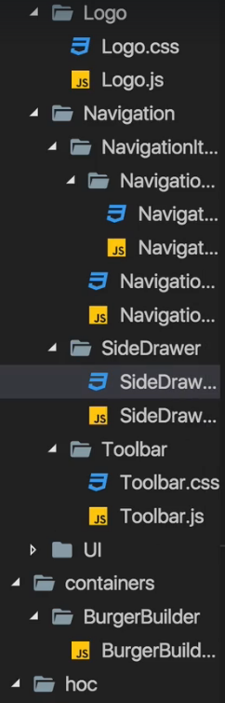   
* The SideDrawer will only be opened on mobile devices  
* We’re having z-index: 200 - deliberately having higher number than the Backdrop because the SideDrawer should be above the Backdrop.  
* Now I’ll add a transition property to react to changes of the transform property and animate them over 0.3s with the ease-out timing function. This will be important for opening and closing.  
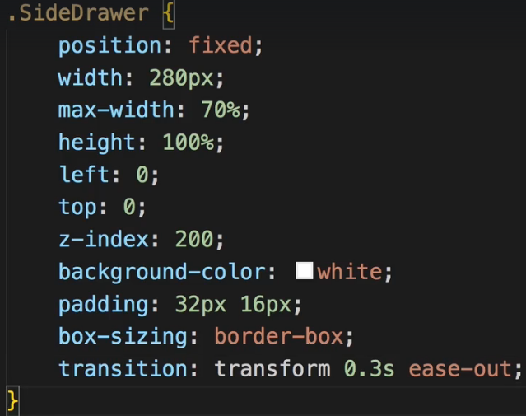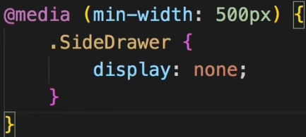  
* The translateX(0) will basically shift the SideDrawer into the position I defined in .SiderDrawer.  
* The translateX(-100%) will shift it to the left.  
* And since we constantly switch between these classes, transform will be adjusted and hence it’ll play with the transition.  
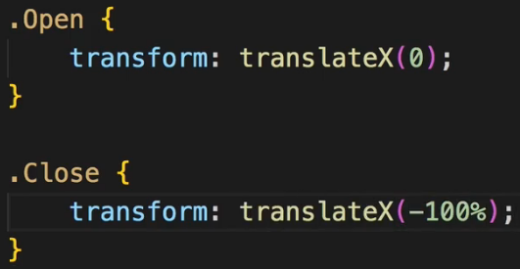  
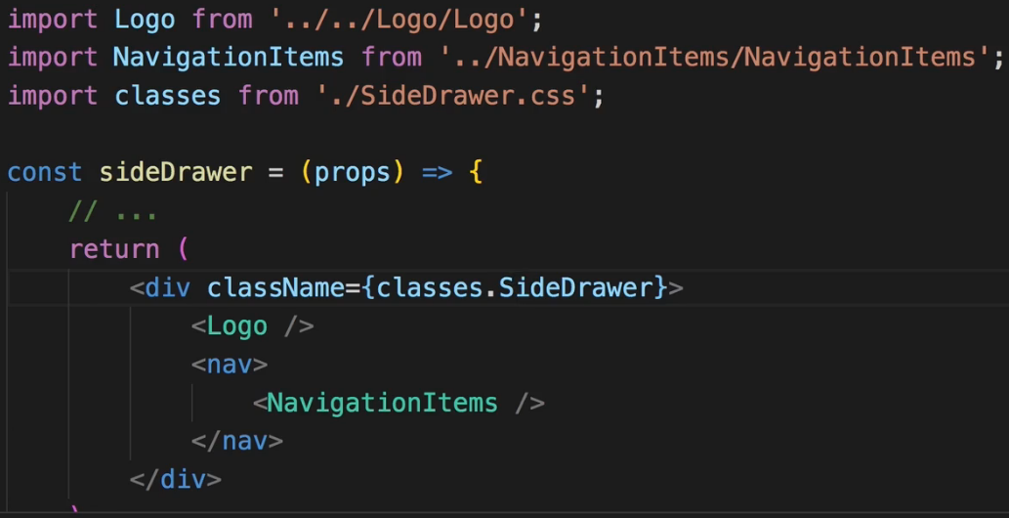  
* Where should this SideDrawer component be used at?  
* In the App.js? In the Toolbar.js? Neither of the two of course. We got our Layout.js and in the Layout we have the Toolbar, it’s here where we should also have the SideDrawer because it’s part of our core Layout in my opinion.  
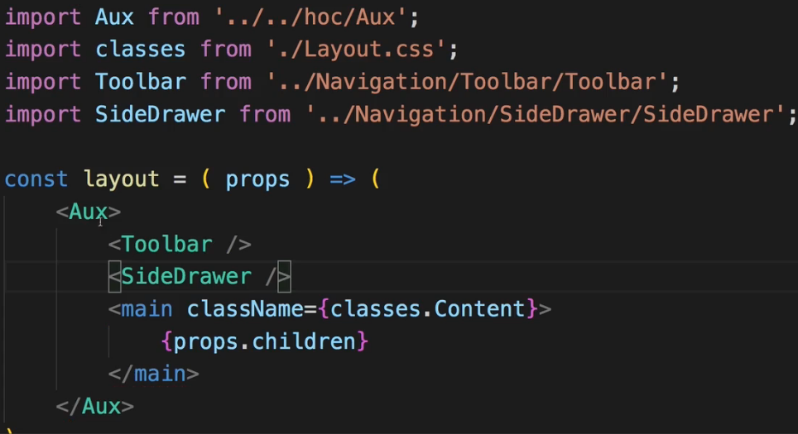  
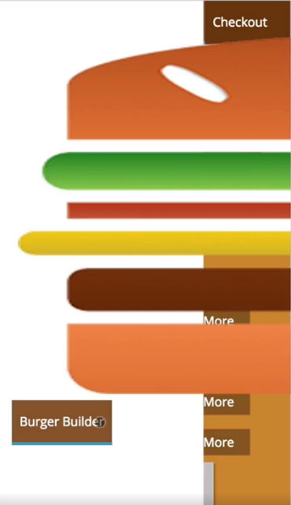  
=> Now the Logo is way too big and the NavigationItems of course look bad. That makes sense because we haven’t adjusted them to look good on mobile devices.  
**Working on Responsive Adjustments**  
* We could add some responsive design to the Logo.css, could set the default height: 11% and add a media query to ramp this up to 80% for bigger screens but that would make our Logo harder to reuse.  
=> Instead, I’m a fan of controling the Logo height in the place where we embed it instead of in the Logo component.  
=> So I will actually set the Logo.css height back to 100%.  
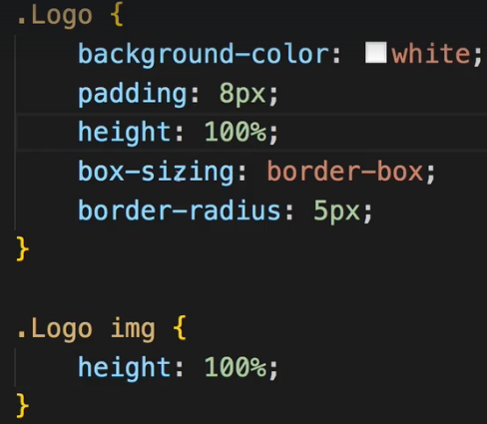  
* And we should restrict this height in the Toolbar and in the SideDrawer.  
* We can achieve this in 2 ways - we could add a prop to actually set the height dynamically and we could set the inline style={} in Logo component to overwrite the CSS class settings.  


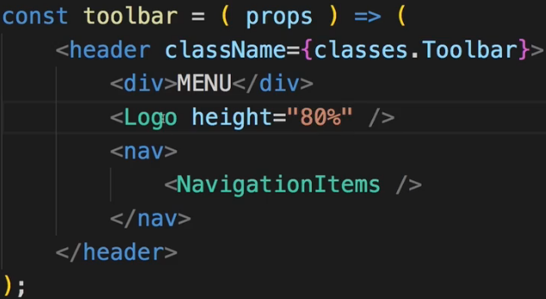 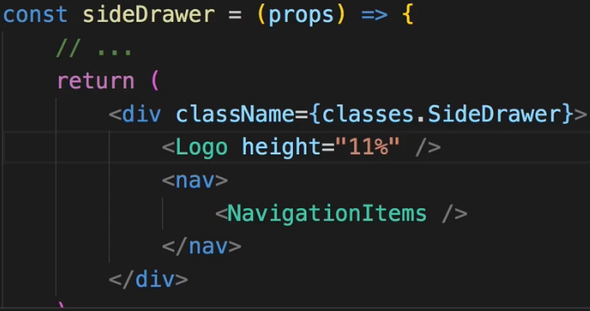  
=> This is 1 clever way of adjusting this - setting the height as a property where we simply pass the % height to the Logo component and in the component, assign it dynamically via inline styles.  
=> Nothing wrong with this approach, it should look fine.  
* I will leave the class in the SideDrawer but will do something else.  
* I will follow a different approach and wrap Logo into a DIV in the SideDrawer and also in the Toolbar. And now these DIVs which wrap the Logo - they should control the height. We can do this with inline styles or with a CSS class like for example here in the Toolbar classes.Logo. And the cool thing is I can now use the Logo class here in the Toolbar component even though I’m already using it in the Logo component because due to CSS Modules, it will convert my CSS class names into different names, into scoped names so that even though I write 2 identical classes in the development mode here, it actually converts that to 2 different classes which get assigned so that they don’t interfere.   
=> So now I can define that .Logo class in my Toolbar.  
* In Toolbar.css: * In SideDrawer.css:  
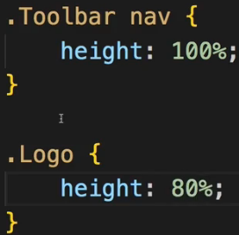 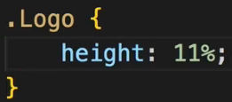  
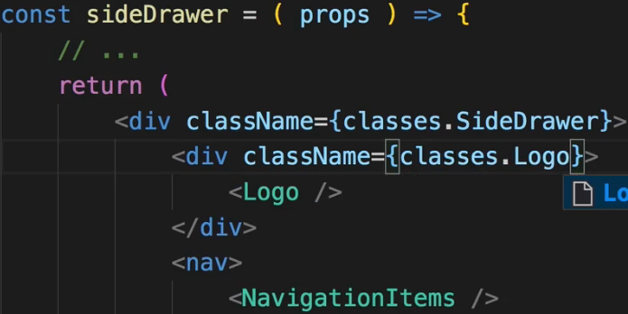 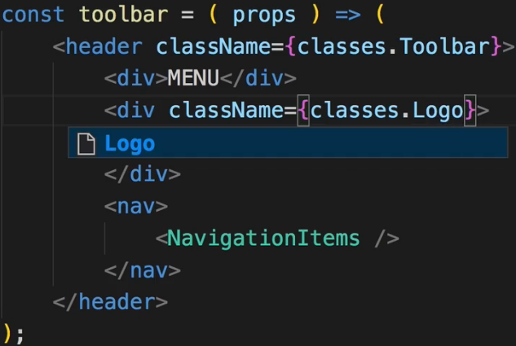  
* And again I have that .Logo class defined in 3 different files but due to CSS Modules this is actually converted to 3 different CSS classes.  
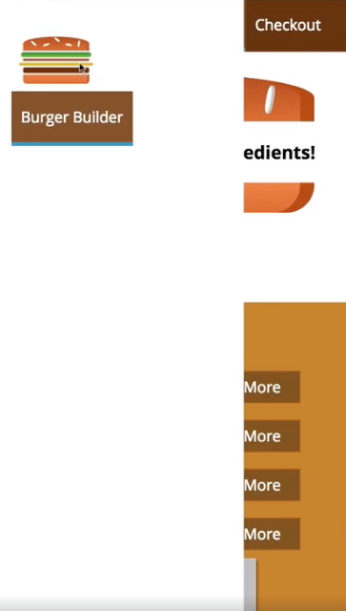 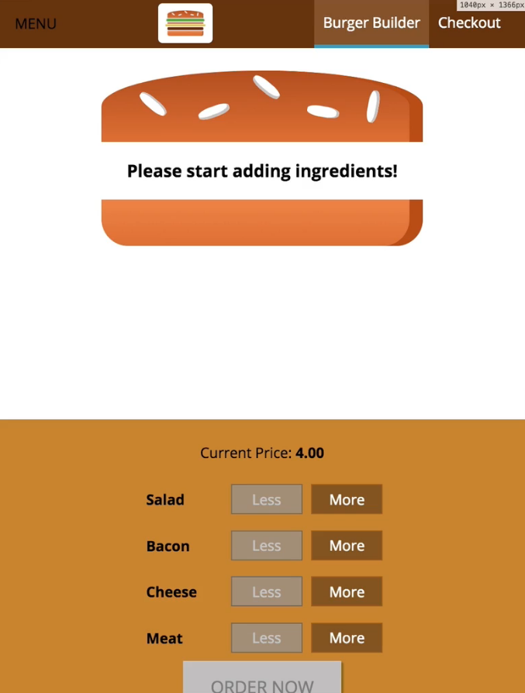  
**More about Responsive Adjustments**  
* Let’s adjust the NavigationItems with media queries in the NavigationItems.css file.  
* Currently we have it only for desktop, we will move that into a media query.  
* And now in the base styles we wanna adjust it for mobile devices.  
* I want to set the width: 100%, not the height - the height should be only taking the height it needs from a text perspective. And the display doesn’t have to be flex, it can be block here. And I don’t need that align-items for that reason.  
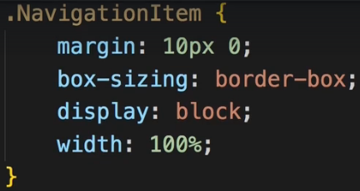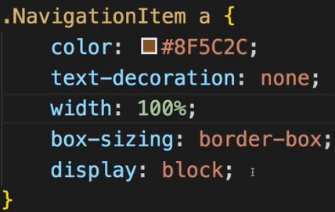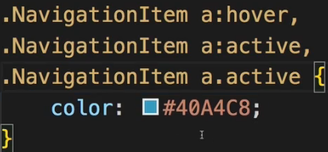  
* Now let’s throw out any duplicate styling we have in desktop media query.  
* For desktops we will use width: auto, not the 100%.  
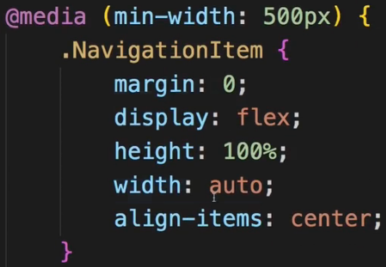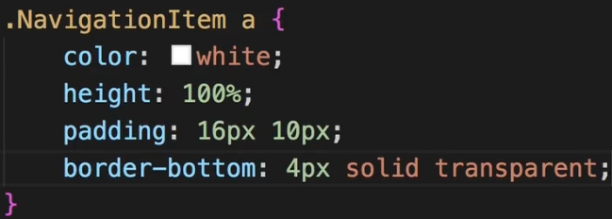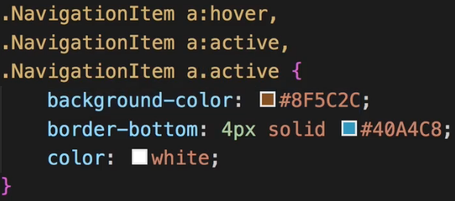  
  
* Now they’re still sitting next to each other - the reason for this is that in our NavigationItems the UL which wraps the links - there we’re using flexbox.  
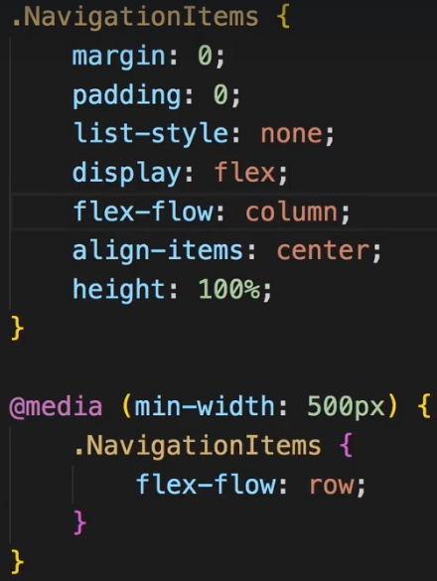 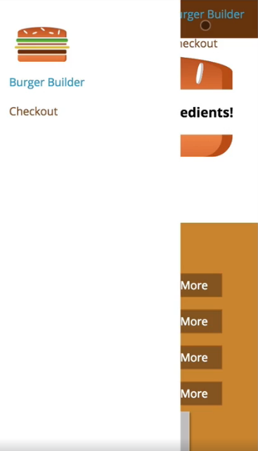  
* When using Chrome Dev Tools different heights/width - the distorted burger when switching is only due to the switching, once you reload and load the app as the user would see it, it’s looking fine.  
* Now we got issues here - the NavigationItems are also visible on the Toolbar on smaller screens, I also want to have a bit more spacing between the logo and my NavigationItems here.  
=> To fix this, in the SideDrawer where I include the Logo and the NavigationItems, I’ll first of all add some margin-bottom on the Logo.  
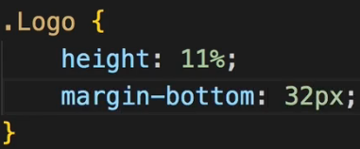  
* And to remove the NavigationItems in the Toolbar we actually need to add a new helper CSS class which I’ll add to the wrapping element. We use max-width media query so that it applies to mobile devices.  
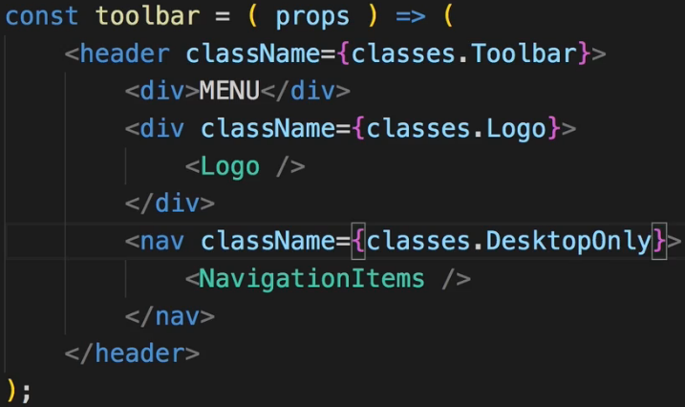 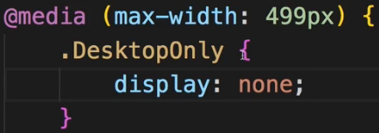  
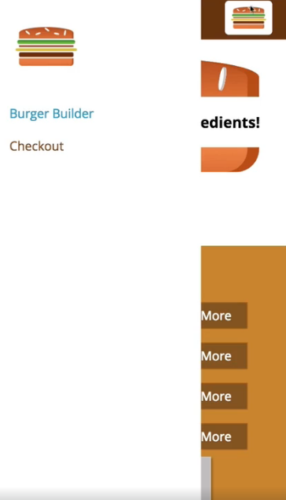  
=> We see the Logo here on the right but I think that looks quite nice so maybe we’ll leave that here.  
=> It would look even better if it had a Backdrop and if we could dynamically open and close it.  
**Reusing the Backdrop**

* Just as I added it to the Modal component - I included it in the Modal component, I want to include it in the SideDrawer component too because it belongs to the SideDrawer.  
* To solve the adjacent elements we can import our **Aux HOC**. --- or use **FRAGMENTS <> </>**.  
* Now we don’t see the Backdrop though - our Backdrop.js has this props.show to display it.  
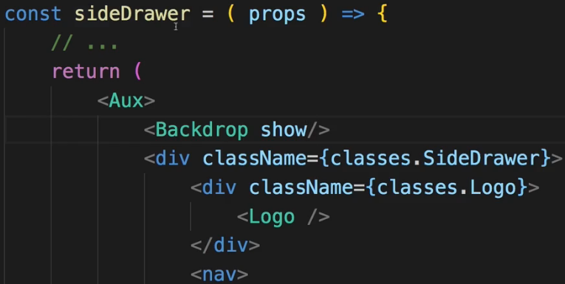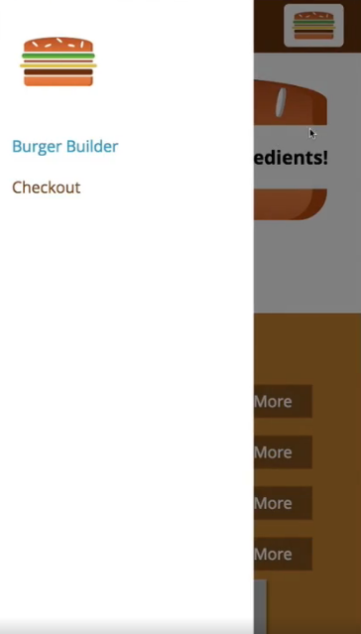  
=> So now we got the Backdrop. This should not always be visible though - the SideDrawer should only be shown sometimes - once we click the menu button essentially and it should also be closed once we click the Backdrop.  
=> So for that we need to register a click listener on the Backdrop and actually we already have one. We have the onClick={props.clicked} which can fire any method we want it to fire.  
=> So the goal is to now be able to handle this method in the SideDrawer. Now in the Modal.js we simply propagated this click up so up to our holding container. Here in the SideDrawer I also want to do this. We could also turn the SideDrawer into a Stateful component and handle the click in here with a method and with a state which we switch from show so from true to false. And there would be nothing wrong with it but we will also trigger the SideDrawer from the Toolbar in the end because there we’ll have the MENU button. So in the end we also need to create a connection from Toolbar to SideDrawer and we have that connection already - it’s the Layout.js component. This is where we use both.  
=> So in my opinion it makes more sense to turn the Layout component into a class component where we can implement the method so that we can listen to both the SideDrawer closing itself by clicking on the Backdrop as well as the Toolbar opening the SideDrawer by clicking on the Toggle menu button.  
=> So let’s turn our Layout into a class and extend (so import) Component from React.   
=> Let’s also change the name if the class to Layout since that’s the convention (Stateful = Capital, Stateless = lower).  
* Let’s set the showSideDrawer to true for testing, later change the default to false.  
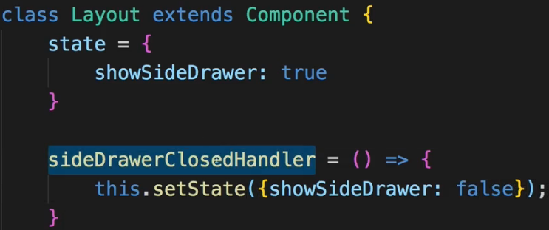  
* Now let’s pass this event handler method to my SideDrawer.  
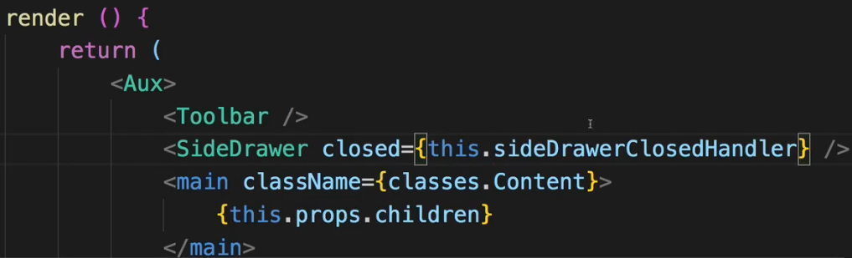   
* In the SideDrawer we’ll use to to simply pass it on to the Backdrop where I have this clicked property which will simply pass me the onClick event basically.

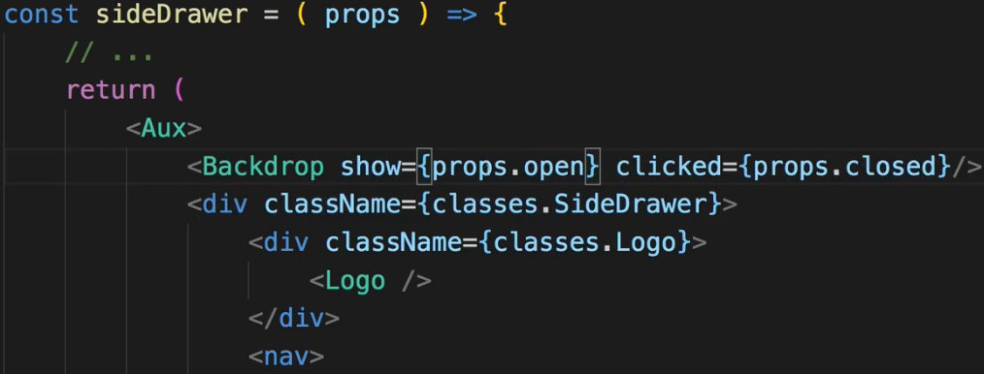  
=> So simply setting up this chain where I pass down the method reference to the place where I handle the click in the end.  
* We also pass this show from Layout.js state.  
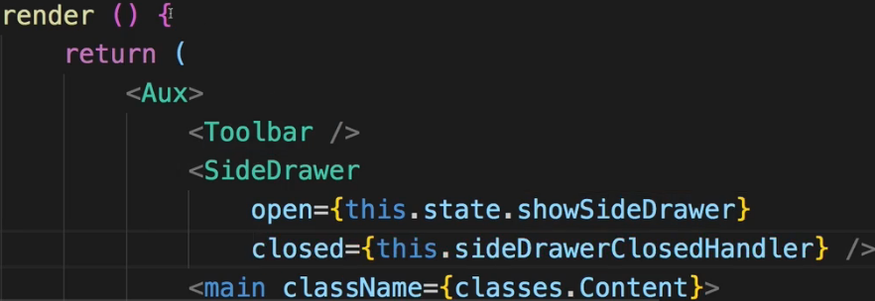  
=> Now if we click the Backdrop, it dismisses the Backdrop. It doesn’t dismiss the SideDrawer yet because we haven’t implemented any logic to do so. Let’s do it now.  
=> We have the .Open and .Close CSS classes in the SideDrawer.css file. I want to attach these classes conditionally because they will basically move the SideDrawer out of the page or into it and they will play an animation with it due to that transition property here.  
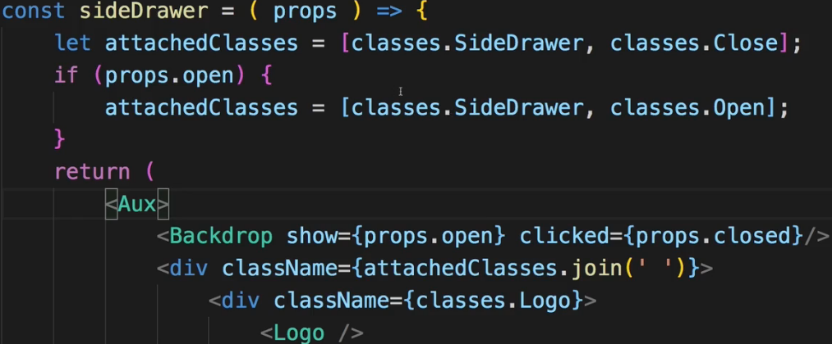  
* Now both the SiderDrawer and the Backdrop disappear when we click the Backdrop.   
**Adding a SideDrawer Toggle Button**  
* Let’s now implement a component which allows us to click on it and which will then trigger something which shows the SideDrawer. There are certainly more than 1 way of achieving this.  
=> For example by not creating a component and simply hooking up this DIV “MENU” with click listener to take an easier route. Or outsource this into its own component, maybe create a Hamburger icon there, make it clickable and in the end make sure that you somehow get to the Layout component and adjust the state to set showSideDrawer to true. Set if false initially. And make sure that you now can somehow click something in the Toolbar, set the state here as I just said and therefore change the open property of the SideDrawer because it’s dependant on the showSideDrawer state.  
=> We want to make sure that we can click this “MENU” button in the Toolbar. And I want to outsource “MENU” into its own component which I want to also style as a hamburger icon.  
=> I’ll place this component in a SideDrawer folder because it belongs to the SideDrawer and I’ll name it `DrawerToggle`.  
* I will add this DIV “MENU” as a placeholder but I will change this to a hamburger icon later.  
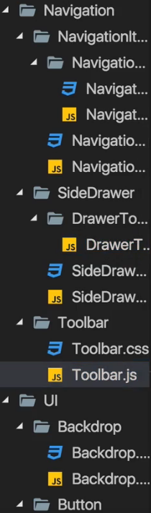 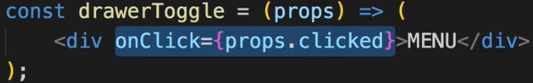 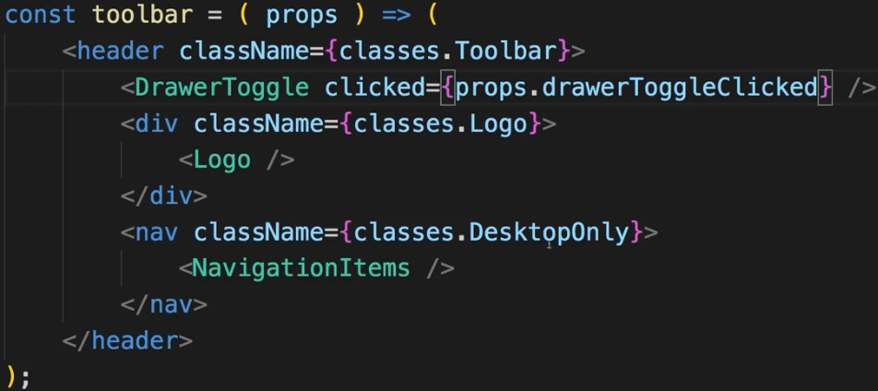  
* Now the goal is to add a click listener to the DIV here.  
* Now in Toolbar let’s add that clicked property to the DrawerToggle and there of course we don’t have that method defined in here - but we will use the Toolbar in the Layout component where we will add this method. So ultimately we will set some property on the Toolbar and pass down the method reference from there.  
* Now in the Layout.js we’ll add that sideDrawerToggleHandler. Now it actually will work as a toggle so from open to close and the other way around, but in our app we will never be able to see that close functionality because the SideDrawer will overlap it - I’m still going to create it in this way because if we ever were to add this toggle in some other place in the app, it would really work as a toggle.  
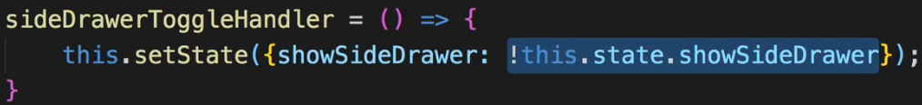  
=> This approach here has a flaw though. I mentioned earlier that if you plan on using the state in setState(), you shouldn’t do it like this because due to the asynchronous nature of setState(), this may lead to unexpected outcomes.  
=> So instead, use the **function form of setState()**. This is the clean way of setting the state when it depends on the old state.  
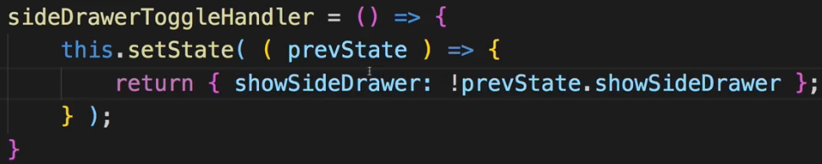  
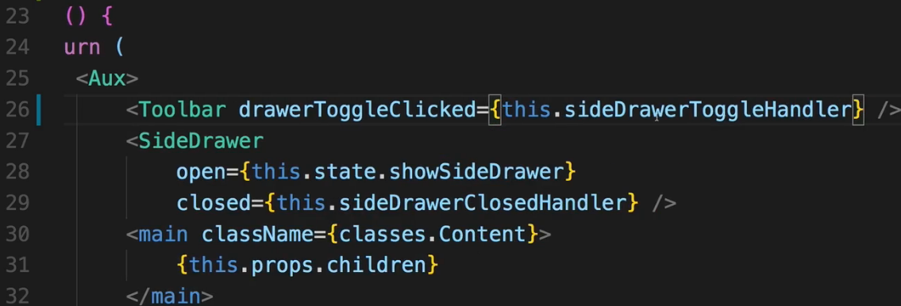  
=> Now if we click the “MENU” button, the SideDrawer slides in. Let’s now turn this “MENU” text here into a hamburger icon.  
**Adding a Hamburger Icon**  
* We add DrawerToggle.css file.  
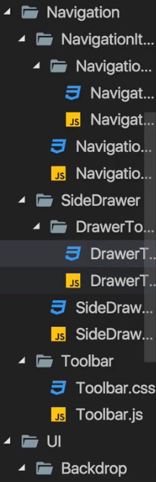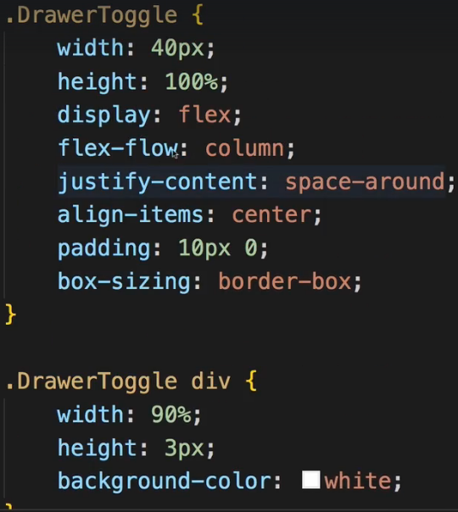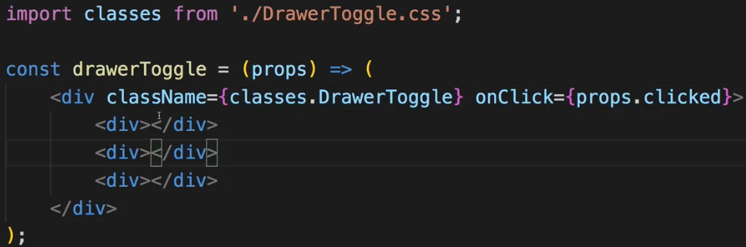  
* Now attached to this video you will find the CSS code which is responsible for styling it as a hamburger icon.  
=> Now this code essentially just creates a DIV with 3 bars inside of it where each bar is one of the hamburger icon bars.  
=> Now to make this CSS code work, we need to adjust the actual HTML(JSX) code instead of just the “MENU” text.  
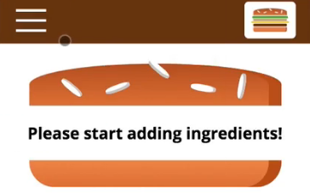  
* Now later we’ll add more functionality like sending this order data to a real server, adding multiple pages and handling the application’s state differently.  
* Let’s now have a look at how we may optimize this or what we can fine-tune about that.  
**Improving the App - Introduction**  
* Of course we want to have a really good application not only by the looks of it but also by the way we structure it, we work with it.  
* Now throughout building this application, I already showed you a lot of best practices for building that, I shared my thought process on how to structure and plan the application and I gave you some alternatives at some points of time on how you may split something into components.  
* Here we have a relatively granulad component structure. You could certainly combine some of the components we’re using.   
* But can you also improve some things? Let’s dive into 2 important things we learned about:   
=> PropTypes  
=> PureComponents - so shouldComponentUpdate()  
=> And let’s also have a look at all these Lifecycle methods. Do we use them in there? Why don’t we use them at any point right now? Where would we use them?  
**Prop Type Validation**  
* Right now we’re doing Prop Type Validation in BurgerIngredient component.  
* There we make sure that the `type` is set so that it is required and that it is a string.  
* I’m not doing validation in any other component.  
* And the reason for this is that here I’m not working on a project which is going to get used by other people, I’m not working on a third-party library, I’m not even working in a developer team, so a lot of the reasons why properties might be used incorrectly aren’t relevant here. Additionally, we’ll get logical errors in our application if we forget or assign a wrong key property anyways and that is why I don’t use Prop Type Validation that much in this application.  
* If you add some Prop Type Validation, just keep in mind that you’d have to have Stateful Components, which isn’t bad per se, you can absolutely do that but it’s also good practice to not unnecessarily do that and instead use as many Stateless, Functional Components as possible. And therefore only really do it if it makes sense.  
**Improving Performance**  
* What about PureComponents and shouldComponentUpdate()?  
* Now let’s analyze the application:  
=> Do we have any state or prop changes which trigger a re-rendering even though this might not be required?  
* Most clicks we do really change the UI and therefore should trigger updates, should trigger re-renderings of these components.  
=> So we shouldn’t really lose performance there. And using a lot of PureComponents for unnecessary shouldComponentUpdate() checks might even hit the performance more than doing an occasional unnecessary re-rendering.  
=> Crucial points we should check are of course our: BurgerBuilder Cointainer - there we change the state but whenever we do change the state, it really affects our application and we do need to re-render stuff.  
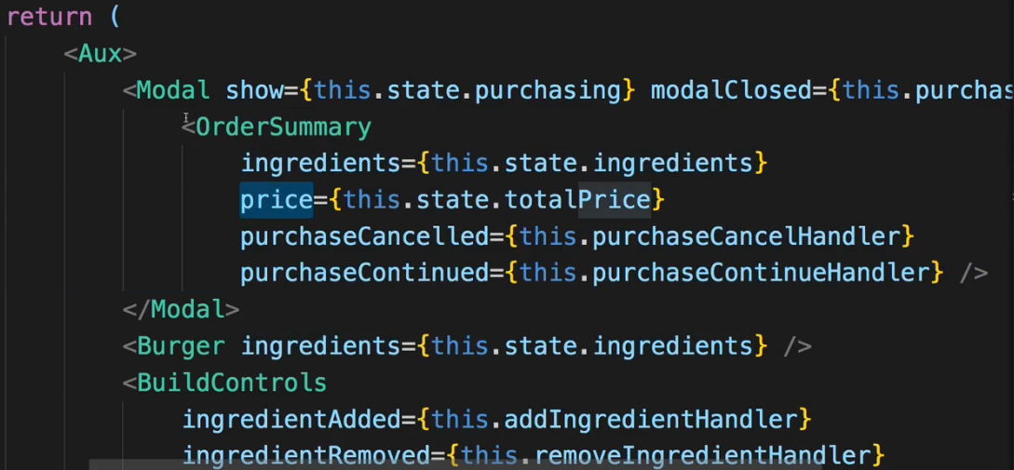  
=> I can identify 1 element here though, where we might be able to save some performance by not re-rendering it unnecessarily and that is the Modal component. It wraps the OrderSummary and that of course means that whenever ingredients or the price changes since these are props of OrderSummary, OrderSummary will be re-rendered, however, if the Modal is not visible, we don’t need to do that.  
=> So actually only if the Modal is shown, re-rendering of that wrapped element here makes sense. So that is something we might wanna check and control.  
=> So let’s first of all find out when OrderSummary is re-rendered by simply adding a Lifecycle Hook to it.  
=> Let’s turn it into a class component so that we can add Lifecycle Hooks so that we can see when this is updated.  
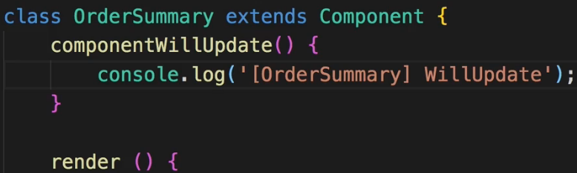  
=> If we add an ingredient, the OrderSummary updates. So it doesn’t really make sense to re-render that when we don’t see it.  
=> Now let’s see if that changes if we make sure that Modal doesn’t update unnecessarily.  
=> For that let’s turn Modal into Stateful Component as well so that we can implement shouldComponentUpdate().  
=> Let’s now see if we can control the updating of OrderSummary - which is wrapped by the Modal, by changing the way the Modal itself updates.  
=> Now I want to make sure that this only updates if this.props.**show** changes. Because that’s the only thing which matters for me here.  
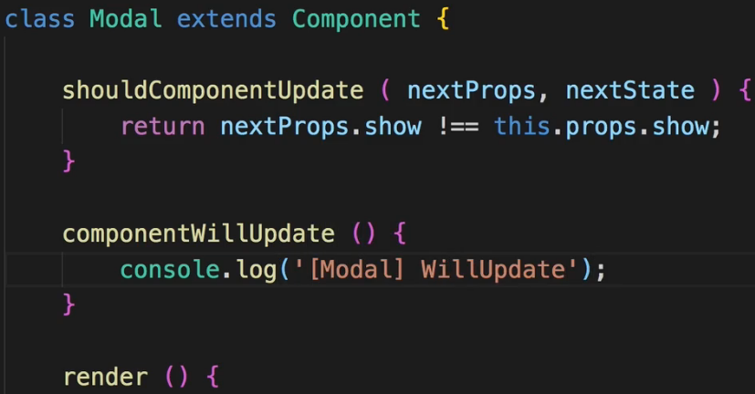  
=> Now it updates once we click ORDER NOW  
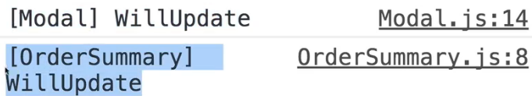  
=> So here we definitely improved our application because we make sure that we don’t unnecessarily update OrderSummary, that we don’t unnecessarily re-render that.   
=> And you also see that **the wrapping element controls the updating of the wrapped element**.  
=> So OrderSummary theoretically - the component - is included in the BurgerBuilder but it is not updated because the wrapping element Modal has a shouldComponentUpdate() method where we control this.  
* What we don’t do - we don’t react to changes in the clicked listener so if the `modalClosed` property would change, we’re not checking this. So we only return true if the `show` changed. It’s okay here in this application because we actually never reassign this clicked listener. If we were to do that, or if we were to also change `state` in the Modal, we definitely should also check for changes in other props, other state properties, or simply extend PureComponent.  
=> Here I’m not using PureComponent because PureComponent would run more checks than I want to do - it would also check for `modalClosed` to be changed and I’m not interested in that so my method should be even more straight forward, even more focused.  
* Now with that we can of course also turn our OrderSummary back into a Functional Component to no longer output componentWillUpdate() here but I’ll leave it here for debugging purposes, for reference, but I will comment that this could be a Functional Component.  
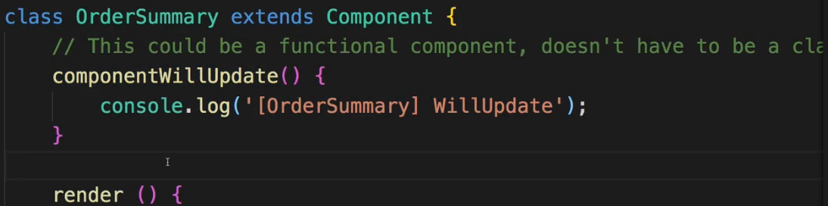  
* shouldComponentUpdate() is definitely not required here because we don’t need to check this, this always needs to be updated if the Modal is shown and the Modal is where we do check whether it needs to be updated or not.  
**Using Component Lifecycle Methods**  
* Now what about other Lifecycle Methods like componentDidMount() or componentDidUpdate() and all these things? Why don’t we use any of them? When would we use them?  
=> Well actually you will see some of them being used once we add HTTP.  
=> As you saw in the slides in the last course module, **the componentDidMount() and componentDidUpdate() Lifecycle Hooks are extremely important** **for causing side-effects**.  
=> That shoulds strange but in the end just means things like reaching out to a web service and fetching data from there. Now we’re not doing that yet in the application. There isn’t much initialization we have to do in our components. That is why we don’t need the Lifecycle Hooks.  
=> Other Hooks like componentWillUpdate() and so on which we don’t use except for logging here, well you typically don’t use these that often. **There might be some cases where you need to adjust your component STATE based on some PROPS you receive from outside and that certainly can occur in bigger React applications but it’s also not that uncommon to have React applications where you don’t use that many Lifecycle Hooks except for componentDidUpdate() maybe**. So that is the reason why you don’t see that many of these being used. There will be more once we add HTTP.  
* It’s a pretty good application, showing a lot of features of React and a lot of best practices so let me now summarize it in the next lecture.  
**Changing the Folder Structure**  
* Our Layout.js is clearly a Class-based Component and it has a STATE, a state to handle the display of the SideDrawer.   
* Now I don’t really consider it to be a Container though you could argue for it to be one because obviously it contains some other components and it passes state down to them. So it wouldn’t necessarily be wrong to place that Layout component here in the `containers` folder. Like this:  
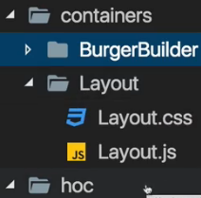  
* You could also argue for something different - with the given folder structure, which of course is also just 1 possible way, where I have this `hoc` folder for Higher Order Components, you could kind of argue that the Layout.js is really just a HOC because what you’re doing with it is you’re wrapping your other components with the Layout. So the BurgerBuilder component in our application, but once we add ROUTING, that of course are going to be more components. And in the App.js folder we’re really just wrapping the BurgerBuilder with our Layout component. And this essentially makes it a HOC. These are mainly just semantics - it doesn’t really change the way your application works the how you call your components.  
* Still you could move the Layout into `containers` or you could move it into `hoc` or maybe in your application you don’t really have a `hoc` folder. Maybe there you just have `containers` and `components`. There is more than 1 correct way.  
* Now I like this setup though where the Layout is now in the `hoc` folder because I consider it a HOC. It’s only there to wrap other components. And therefore here we’re using it in the App.js file to wrap whichever ROUTER rendering, hence I move it into the `hoc` folder.  
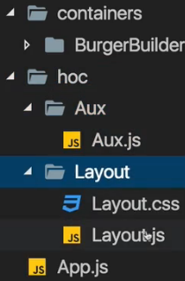 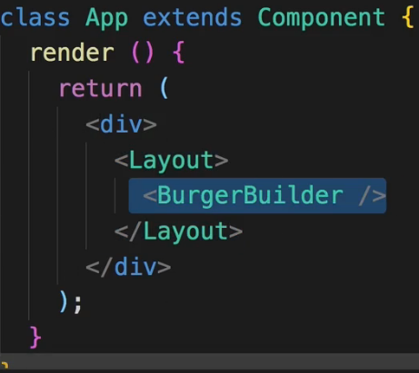  
* Now this will lead to some errors because we will have some import issues.  
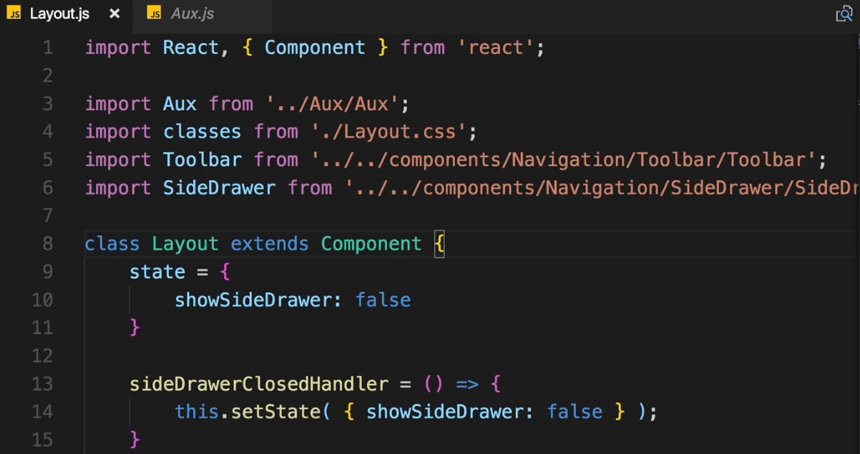  
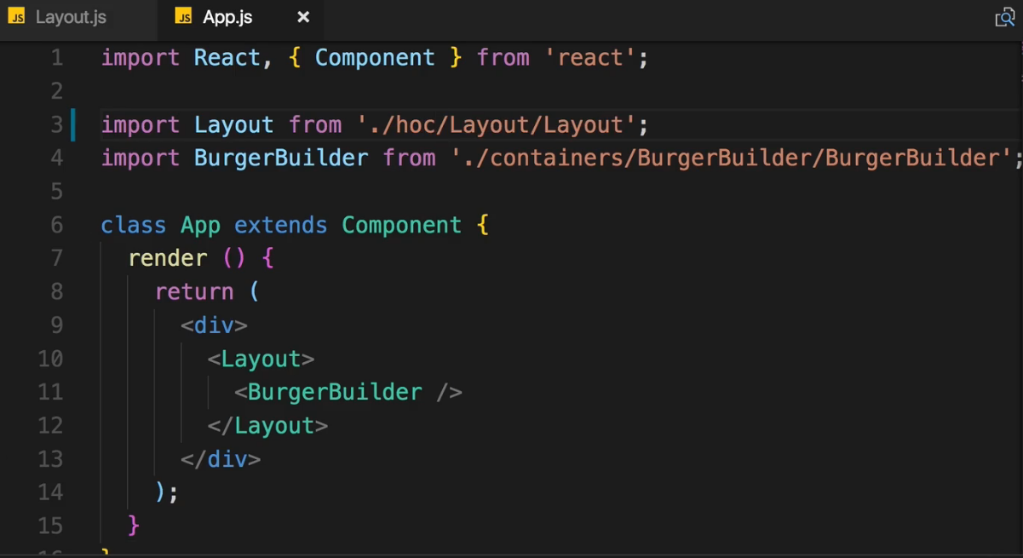  
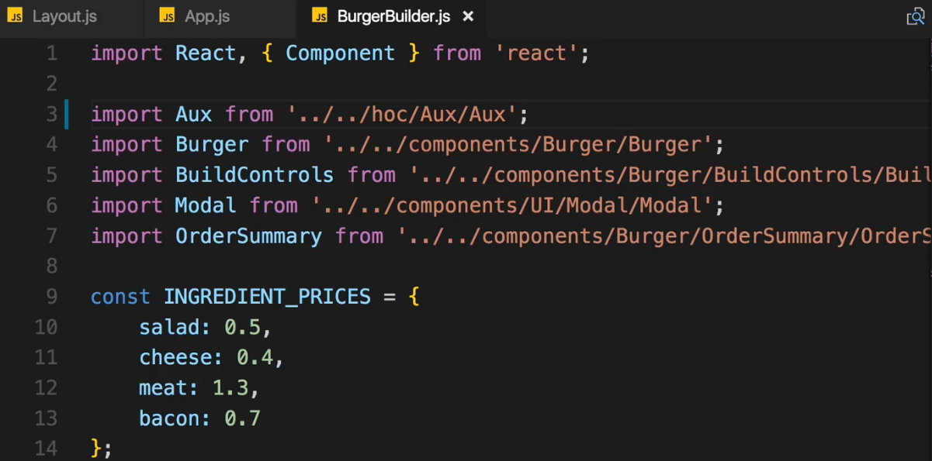  
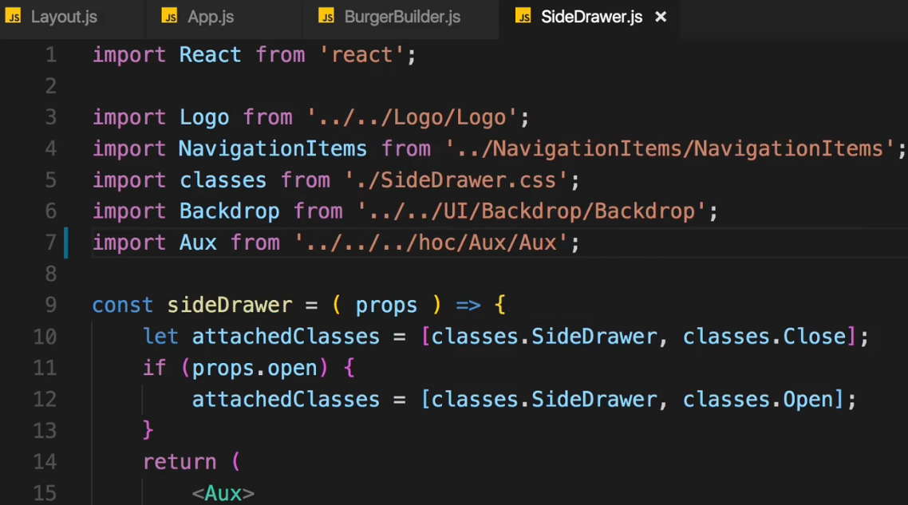  
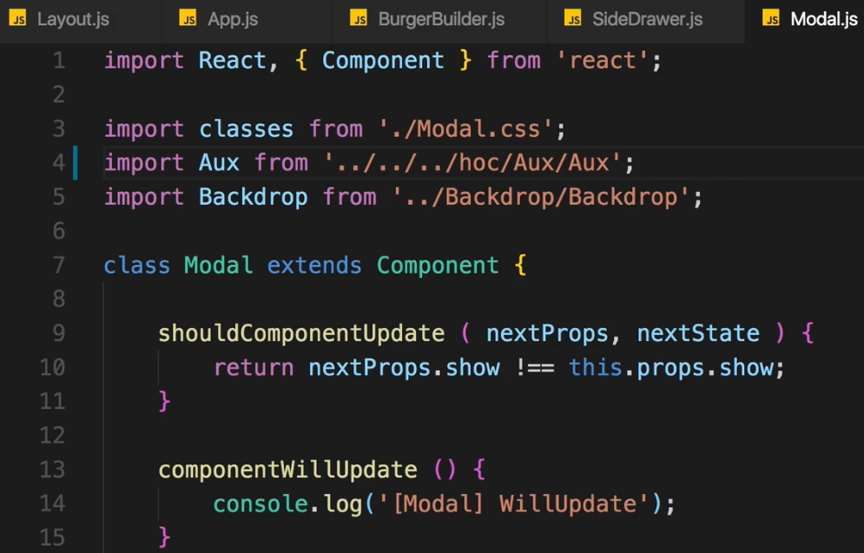  
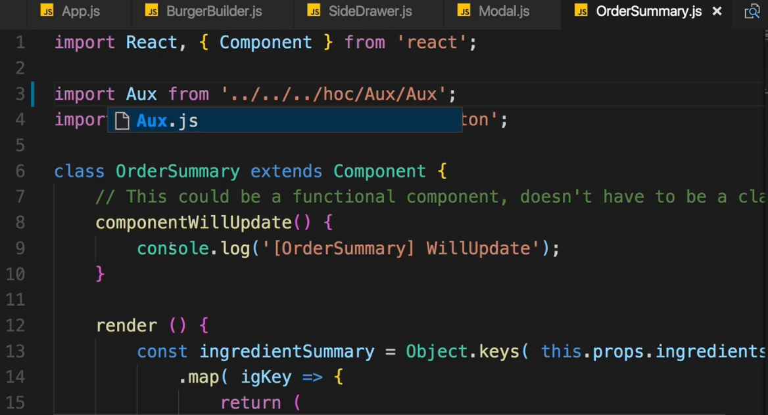  
=> With all these changes now we should have a working application again.  
* This new project structure is optional but makes more sense in my opinion due to the way our components do work.  
* Now with that we really have a great application, let’s now move on.  
**Wrap Up**  
* You learned how to plan your application, how to split it into components, how to have these components communicate with each other via PROPS, how to pass METHOD REFERENCES to components so that a CLICK on the BACKDROP triggers a METHOD in ANOTHER COMPONENT like in the LAYOUT component in our case.  
* These are all CORE CONCEPTS of Modern React Applications.  
* Being aware of how to communicate, how to structure it, how to build the components and the pitfalls React offers.  
* Being aware of concepts like the **Aux/Auxiliary HOC** --- newly **FRAGMENTS <> </>**.  
* Or the shouldComponentUpdate() mechanism.  
* These are crucial to building successful React apps.  
=> We’ll learn much more: how to reach out to the WEB to SAVE your DATA there or FETCH it from there.  
=> You will learn how to handle STATE in a BETTER WAY.  
=> How to ROUTE.  
* But here you got solid foundations and you can play around with this project, enhance it a little bit, add some features, change the styling, add other components, add more ingredients to the burger, whatever you like.   
* Building projects is the best way of learning anything.